 | Check Point Threat Extraction secured this document |  | Get Original



GIRESUN PORT DANGEROUS CARGO HANDLING GUIDE

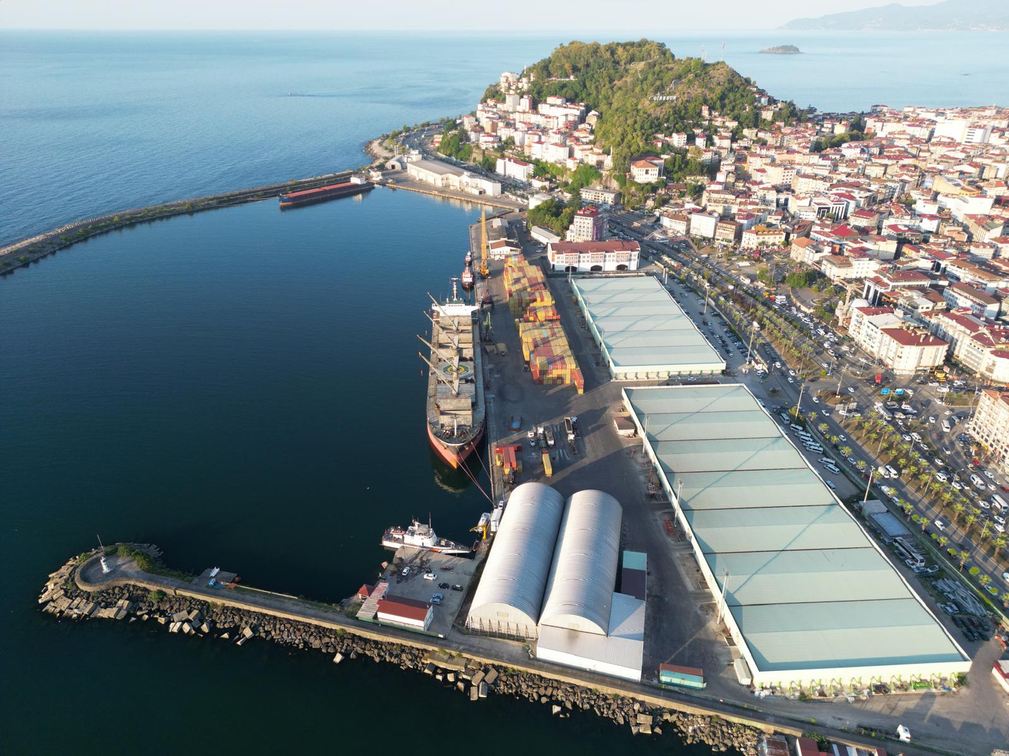

PREPARATION DATE:31.12.2015
(See Revision Page for Revisions)

MURAT SOLAK
Terminal Manager

REVISION PAGE

Sequence No. | Revision Number | Content of the Revision | Revision date | Revision Maker
 |  |  |  | Name and  surname | signature
1 | 01 | New Release | 31.01.2018 | Murat  SOLAK
2 | 02 | Content Update | 26.02.2021 | Eren Can  BAŞARIR
3 | 03 | Liquid Bulk Cargo  cancellation | 02.06.2021 | Eren Can  BAŞARIR
4 | 04 | Adding Packaged  Dangerous Cargo | 03.09.2021 | Eren Can  BAŞARIR
5 | 05 | TYER Instruction  Update | 01.06.2022 | ELIF  KAPLAN
6 | 06 | Content update | 01.02.2024 | ELIF  KAPLAN

Contents
- LOGIN 11
  - Loading/Discharging, Handling and Storage Procedures for Dangerous Goods Handled and Temporarily Stored at the Coastal Facility 15
    - The Dangerous Goods Handled and Temporarily Stored in Our Shore Facility are as follows. 15
    - Loading/Discharging Procedure for Handled and Temporarily Stored Dangerous Goods: 15
    - Handling and Storage Procedures: 16
- RESPONSIBILITIES 21
  - Responsibilities of Cargo Person: 21
  - Responsibilities of the Coastal Facility Operator: 21
  - Responsibilities of Ship Person: 23
  - Responsibilities of the Carrier 24
  - Dangerous Goods Safety Advisor Responsibilities 24
- RULES TO BE APPLIED BY THE SHORE FACILITY AND MEASURES TO BE TAKEN: 26
- CLASSES OF HAZARDOUS LOADS, TRANSPORTATION, LOADING/UNLOADING, HANDLING, SEPARATION, STACKING and STORAGE 27
4.1 Classes of dangerous goods: | 27
4.2 Packages and Packages of Dangerous Goods | 28
4.3 Placards, Plates, Brands and Labels for Dangerous Goods | 29
4.3.1 Placards | 29
4.4 Signs and packing groups of dangerous goods | 30
4.5 Separation Tables for Dangerous Goods on Board and in Port: | 31
4.6 Separation Distances and Separation Terms of Dangerous | Goods in
Warehouse Storages: | 33
- HANDBOOK ON DANGEROUS LOADS HANDLED ON THE COASTAL FACILITY 33
- OPERATIONAL MATTERS 33

  - Procedures for safe berthing, mooring, loading/discharging, sheltering or anchoring of ships carrying dangerous goods day and night. 33
  - Procedures for additional measures to be taken according to seasonal conditions for the loading and unloading of dangerous goods. 34
  - Procedures for Keeping Combustible, Flammable and Explosive Loads Away from Spark-Creating/May Create Operations and Not Operating Vehicles, Equipment or Tools that Create/Create Sparks in Dangerous Goods Handling, Stacking and Storage Areas: 35
- DOCUMENTATION, CONTROL AND REGISTRATION 39
  - All mandatory documents, information and documents related to dangerous goods, procedures for their supply and control by the relevant people. 39
  - Procedures for Keeping Up-to-Date List of All Dangerous Goods in the Coastal Facility Site and Other Related Information Regularly and Completely: 39
  - Procedures for Controlling Dangerous Goods Arriving at the Facility Properly Identified, Using Correct Shipping Names of Dangerous Goods, Certified, Packed / Packed, Labeled and Declared, Loaded and Transported Safely to Approved and Legal Package, Contaner or Cargo Transport Unit and Reporting the Control Results:
39
  - Procedures for obtaining and maintaining a safety data sheet (SDS). 40
  - Procedures for keeping records and statistics of dangerous goods. 41
  - Information on the Quality Management System 41
- EMERGENCIES, EMERGENCY PREPAREDNESS AND RESPONSE 41
  - Intervention Procedures for Dangerous Cargoes and Dangerous Situations Mixed with Dangerous Cargoes that Create/Can Create Risk to Life, Property and/or Environment: 41
  - Information on the Opportunity, Capability and Capacity of the Coastal Facility to Respond to Emergency Situations: 43
  - Regulations regarding the first response to the accidents involving dangerous goods (first aid procedures, first aid possibilities and capabilities, etc.) 43
  - Notifications to be made inside and outside the facility in case of emergency 43
  - Accident reporting procedures 43
  - Coordination, support and cooperation method with official authorities 44

  - Emergency evacuation plan for the removal of ships and vessels from the shore facility in case of emergency. 44
  - Procedures for the handling and disposal of damaged dangerous cargoes and waste contaminated by dangerous cargoes 44
  - Emergency drills and their records 44
  - Information on fire protection systems 45
  - Procedures for the approval, inspection, testing, maintenance and availability of fire protection systems 45
  - Precautions to be taken in cases where fire protection systems do not work 45
- OCCUPATIONAL HEALTH AND SAFETY 46
  - Occupational Health and Safety Measures 46
  - Information on personal protective clothing and procedures for using them. 50
  - Closed Room Entry Permit Measures and Procedures 51
- OTHER MATTERS 51
  - Validity of Dangerous Goods Conformity Certificate 51
  - Defined Duties for Dangerous Goods Safety Advisor 51
  - Issues for those carrying dangerous goods that will arrive/leave the coastal facility by road 51
  - Issues for those carrying dangerous goods that will arrive/leave the coastal facility by sea 52
  - Additional considerations to be added by the shore facility 54
ATTACHMENTS 55
- General site plan of the coastal facility 55
- General view photos of the coastal facility 56
- Emergency contact points and contact information 57
- General layout plan of areas where dangerous cargo is handled 58
- Fire plan of areas where hazardous loads are handled 58
- General fire plan of the facility 58
- Emergency Plan 59
- Emergency Assembly Place Plan 59

- Emergency Management Scheme 60
- Hazardous materials handbook 61
- For CTU and Packages Leak areas and equipment, entry/exit drawings 61
- Inventory of port service vessels 61
- Sea coordinates of the port authority's administrative borders, anchorage locations and pilot disembarkation/embarkation points 61
- Emergency response equipment against marine pollution in the port facility 63
- Personal Protective Equipment (PPE) Usage Map 63
The use of PPE is mandatory in the entire port area. 63
- Hazardous Substance Incidents Notification Form 64
- Control results notification form for dangerous cargo transport units (CTUs) . 66
- Other required attachments 67
  - Temperature control form 67
- Dangerous Goods Handling Guide Additional Cargo Notification (When necessary) 67

Aim :
The purpose of this guide is Giresun Port Management A.S.to ensure that the dangerous goods transportation activities to be carried out by sea are carried out in an economical, fast, safe, high quality, environment-friendly manner and in harmony with other transportation activities at the GiresunPort Port Facility operated by the Company.

Scope :
This guide
Dangerous goods to be handled at GiresunPort Port Facility, the duties and responsibilities of the Dangerous Goods Safety Advisor, the duties and responsibilities of the ship captain, the cargo person and the coastal facility operator during the loading, stowage, storage, unloading of these cargoes from the transport unit and the ship, notification, temporary storage, covers the measures.

Definitions and Abbreviations:
In terms of the application of this guide;
Ministry:Ministry of Transport and Infrastructure
Emergency:The crisis situation caused by fire, explosion, flood, sabotage, terrorist attack, nuclear explosion and similar events, including natural disasters that stop or interrupt the normal activities of all or certain parts of the GiresunPort Port Facility and require urgent intervention,
Emergency Evacuation Plan:The plan prepared for the evacuation of ships and marine vehicles, personnel, vehicles-equipment from GiresunPort Port Facility in case of emergency, GiresunPort Port/Port Facility:Giresun Port Management Inc. GiresunPort Port Facility operated by
Port Management:GiresunPort Port Facility Operations Directorate, Port Authority:Giresun Port Authority,
Emergency Evacuation:It refers to the evacuation of ships and marine vehicles, personnel and vehicle-equipment from the port in case of emergency.
Freight Related:The sender, receiver, representative and freight forwarder of the dangerous goods,
Coastal Facility:Docks, piers, buoys, platforms and anchorages, approach areas, closed and open storage areas, buildings and structures used for administrative and service purposes, the boundaries of which are determined by the Administration, where ships can safely take and take cargo or passengers or shelter, Giresun Port Management A.S.(GiresunPort Port Facility)

Freight Transport Unit:Designed and manufactured for the transport of packaged or bulk dangerous goods;road trailer, semi-trailer and tanker, portable tank and multi-element gas container, railroad car and tank-wagon, container and tank-container,
Dangerous Goods (Dangerous Goods):International Convention for the Prevention of Pollution of the Seas by Ships (MARPOL) 73/78 Annex I includes petroleum and petroleum products in Annex 1, packaged transported substances and objects given in IMDG Code Chapter 3, characteristic loads given in IMSBC Code Annex 1. Bulk cargoes with the phrase 'B' and 'A and B' in the group box in the table, liquid substances with the phrase 'S' or 'S/P' in the d column titled hazards of the table given in IBC Code Chapter 17, GC Code Chapter 19 'Given gaseous substances, substances that have not yet been included in these lists, but which have the potential to harm life, property, the environment or other substances during transportation due to their physical, chemical properties or the way they are transported, and the packages and cargo transport units in which these substances are carried and which are not cleaned properly,
Ship Captain:Person who manages the ship carrying dangerous goods coming to the port,
Boat:The ship that loads/discharges dangerous goods at the port,
ADR:European Agreement on the Road and International Transport of Dangerous Goods,

Safety Data Sheet (SDS Form):Dangerous substances and preparations;The document containing detailed information on its properties, the safety measures to be taken in the workplaces according to the dangerous properties of the substance and preparation, the necessary information on the protection of human health and the environment from the negative effects of dangerous substances and preparations,

Preparation:Mixtures or solutions of at least two or more substances, Shore Facility Operator:Giresun Port Management INC.' well, Incident Control Center:Port Support Services,
Hot work:Use of open fires and flames, electrical tools or hot rivets, grinding, soldering, burning, cutting, welding or any other repair work involving heat or generating sparks, which may cause danger due to the presence or proximity of dangerous loads in the environment,

Buyer:Real and legal persons who will take delivery of the dangerous cargo in accordance with the transport contract,

PACKAGING:The transport container in which the dangerous cargo is placed, as defined in IMDG Code Chapter 6,

Packed by:Natural and legal persons who place dangerous goods in different types of containers, including large packaging and intermediate bulk containers, and make the packages ready for transport when necessary, pack dangerous goods or change the packages and labels of these goods, label them for transportation, sender or real and legal persons who carry out these operations with his instructions. and the land and shore facility personnel who actually perform this operation,

Bulk load:Substances in solid, liquid and gaseous state that are the structural part of the ship or are in a tank or hold permanently fixed in or on the ship, intended to be transported directly without containment,

Handling:Without changing the essential characteristics of the dangerous cargo, changing its location, transferring it from large containers to small containers, ventilating, separating, sifting, mixing, renewing, changing or repairing the cargo transport units and packages, and similar operations for transportation,

Fumigation:The process of applying chemical substances in the form of solid, liquid or gas that act in gaseous form to a closed cargo transport unit or ship hold in order to destroy harmful organisms,

IBC Code:International Code on the Construction and Equipment of Ships Carrying Dangerous Chemical Cargo in Bulk,

IGC Code:International Code on the Construction and Equipment of Ships Carrying Liquefied Gas in Bulk,

IMDG Code:International Code for Dangerous Goods Transported by Sea,

IMO:United Nations International Maritime Organization, IMSBC Code:International Maritime Solid Bulk Cargo Code, ISPS Code:International Ship and Port Facility Security Code,
Administration:Dangerous Goods and Combined Transport Regulation General Directorate,

Container:A load carrying equipment that has a certificate in accordance with the applicable standards within the scope of the CSC Contract,

SOLAS:International Convention for the Safety of Life at Sea, 1974,

Bearing:Actual carrier, broker, ship owner, freight forwarder, freight forwarder, shipping agency, who receives, submits and accepts offers for the transportation of all kinds of dangerous goods on their own behalf or on behalf of third parties, together with the dangerous cargo

transportation by road or rail within the scope of combined transportation. Natural and legal persons who carry out the transportation with or without a contract,

Dangerous waste:The parts and solutions of the cargo or the dangerous cargo that is not directly used, or of the packages and cargo transport units carrying dangerous goods, which are classified as specified in the Basel Convention and whose transport class and conditions are determined within the scope of SOLAS, which are transported for reprocessing, garbage, incineration or disposal by any other means. , mixtures and used packaging and cargo transport units,

Uploaded by:In accordance with the instructions of the sender, natural or legal entities that load dangerous cargoes and cargoes that pose a danger in terms of loading safety to the ship or sea vehicle, vehicle or cargo transport unit, label, plate the cargo transport unit, handle, stack and unload the cargo including the dangerous cargoes in the ship or cargo transport unit. people,

- LOGIN
  - The entry and possession of dangerous goods in the coastal facility, the subsequent handling, the general safety and protection of the area, the protection of the cargo, the safety of everyone at or near the coastal facility and the protection of the environment should be controlled.
  - Safety of life at sea is also related to the safety and protection of a ship, its cargoes and crew at the coastal facility, and the precautions taken regarding dangerous cargoes before they are directly loaded/discharged and during handling.
  - The recommendations in this guide are limited to dangerous goods in the port area as part of the transport chain.The recommendations in this guide do not apply to dangerous goods that are generally kept in the port area or used in the port area, but the Administration may wish to check whether the said use and storage procedures comply with legal national requirements.

  - Although land, port and sea elements are included in the general transportation chain, it is very important that the people responsible for the issues specified in 1.4 take all kinds of precautions and that all relevant information is given to the people included in the transportation chain and also to the final consignment.Consideration should be given to the possible different requirements for different modes of transport.
  - Safe transportation and loading of dangerous loads is based on the correct and precise application of the regulations for the transportation and loading of the loads in question, and depends on the judgment of everyone who knows the regulations fully and in detail and is informed about the existing risks regarding these issues.This can only be achieved through properly planned and executed training and retraining of the persons concerned.
  - Laws, regulations and relevant publications are under constant evaluation and are revised regularly.It is very important to use only current versions.The contents of these Laws, regulations and related publications are reproduced in the recommendations in this guide only to the extent necessary.
  - In the preparation of this guide, IMDG CODE, IMSBC CODE, IBC CODE and IMO 1216 CR.documents were consulted and information was used.

FACILITY INFORMATION FORM

1 | Facility operator name/title | Giresun Port Management Inc.
2 | Contact information of the facility operator (address, telephone, fax, e-mail and web page) | Sultan Selim Mah. Mustafa Kemal Pasa Boulevard No:9 Giresun  Phone :0 (454) 216 23 82  Fax:0 (454) 212 17 34  Web:www.giresunport.com.tr
3 | Facility name | Giresun Port Management Inc.
4 | City where the facility is located | Giresun
5 | Contact information of the facility (address, telephone, fax, e-mail and web page) | Giresun Port Authority Tel No:0(454) 216 11 06
6 | Geographical region of the facility | Black Sea Region - Eastern Black Sea Region
7 | Port Authority and contact details of the facility | Giresun Port Authority Tel No:0(454) 216 11 06
8 | Mayor's Office and contact details of the facility | Giresun Municipality Tel No:444 4 028
9 | Name of the Free Zone or Organized Industrial Zone where the facility is located | NONE
10 | Validity date of Coastal Facility Operation Permit/Temporary Operation Permit | 20.04.2029
11 | Facility activity status | Own load and  3 additional persons  (x) | Own Burden | 3rd Party
12 | Name and surname of the facility manager, contact details (phone, fax, e-mail) | Murat SOLAK  Phone:0531 298 5979  Fax:0(454) 212 17 34  Email:murat.solak@tiryaki.com.tr

13 | Name and surname, contact details (phone, fax, e- mail) of the dangerous goods operations officer of the facility | Serkan DURMUŞ  Phone:0538 231 60 46  Email:serkan.durmus@giresunport.com.tr
14 | Name and surname of the Dangerous Goods Safety Advisor of the facility, contact details (phone, fax, e-mail) | Elif Kaplan  Phone:0535 360 53 26  Email:elif@tmgddanismanlik.com
15 | Marine coordinates of the facility | Latıtude: 40.91935 (40°55̍09.6̎ ) N  longıtude: 38.38316 (38°22̍̍̍̍ 59.3̎ ) E
16 | Types of dangerous goods handled at the facility (Loads within the scope of MARPOL Annex-I, IMDG Code, IBC Code, IGC Code, IMSBC Code, Grain Code, TDC Code, asphalt/bitumen and scrap loads) | -IMDG Code  - IBC Code  -IMSBC Code  -BLU Code
17 | Types of ships that can approach the facility | General Cargo Ship Dry cargo  Bulk Carrier Container Tanker  Ro-Ro
18 | Dangerous goods handled at the facility (loads other than IMDG Code, among the cargo types in Article 16, will be written separately. Additional cargo request will be sent to the port authority with Annex-1 form. It will be added to TYER when appropriate) | IMSBC Code IBC Code IMDG Code
19 | Classes for cargo handled, subject to IMDG Code | Class 2, Class 3, Class 4.1,4.2, Class 5.1,5.2,  Class 6.1, Class 8, Class 9
20 | Groups in characteristic table for handled cargo subject to IMSBC Code | Group-A, Group-B, Group-(A and B), Group-C
21 | Distance of the facility to the main road  (kilometers) | Direct Connection available
22 | The distance of the facility to the railway (kilometers) or the railway connection (Yes/No) | NONE
23 | Name of the nearest airport and its distance from the facility (kilometers) | Ordu Giresun Airport 30 km
24 | Load handling capacity of the facility  (Ton/Year;TEU/Year;Vehicle/Year) | 4,999,000 tons/year
25 | Whether scrap handling is done at the facility | No

26 | Is there a border gate? (Yes No) |  |  | No
27 | Is there a bonded area? (Yes No) |  |  | Yes
28 | Cargo handling equipment and capacities |  |  | 1 Industrial Excavator with a maximum capacity of 50 tons  1 industrial excavator with a maximum capacity of  17 tons
29 | Storage tank capacity (m3) |  |  | 6500
30 | Open storage area (m2) |  |  | 69.900
31 | Semi-closed storage area (m2) |  |  | NONE
32 | Closed storage area (m2) |  |  | 22.500
33 | Determined fumigation and/or de-fumigation area (m2) |  |  | NONE
34 | Name/title contact details of pilotage and tugboat services provider |  |  | Towage Services;  Giresunport Liman İşletmeciliği A.Ş.  Address:GMK Paşa Bulvarı Sultan Selim Mah. No:9 Merkez/GİRESUN  Communication: 0(454) 216 11 06 Email:  GUIDANCE SERVICES  Pilots within the company;  - Okan KAYA – 0533 734 00 05  - Barış BİRDANE – 0532 762 53 00
35 | Has a Security Plan been created? (Yes No) |  |  | Security Plan is available under ISPS.
36 | Waste Reception Facility capacity  (This section will be arranged separately according to the wastes accepted by the facility) |  |  | Waste Type Capacity (m3)
36 |  |  |  | sludge 35
36 |  |  |  | Bilge 40
36 |  |  |  | dirty water 35
36 |  |  |  | Waste Oil 35
36 |  |  |  | Dehydrated Bilge Oil 25
36 |  |  |  | Toxic Liquid Substance Tank 25
37 | Dock/pier etc. properties of fields
 | Dock / Pier No | Height (meter) | Most (metre) | Maximum water depth (meters) | Minimum water depth  (meters) | Largest Ship  Tonnage and Length  DWT/GRET/Meter

 | 1&2 | 269 m. | 50m | 10m | 7.85 m | 160 m
 | 3&4&5 | 460 m. | 50 meters | 12.50m | 10m | 230 m

  - Loading/Discharging, Handling and Storage Procedures for Dangerous Goods Handled and Temporarily Stored at the Coastal Facility

    - The Dangerous Goods Handled and Temporarily Stored in Our Shore Facility are as follows.
Solid bulk cargo, packaged dangerous cargoes within the scope of the IMDG Code and liquid bulk cargoes defined as 'S' or 'S/P' characteristic group in IBC Code Chapter 17 are handled in the facility.

    - Loading/Discharging Procedure for Handled and Temporarily Stored Dangerous Goods:
1.2.1 General
Among the cargoes defined as class 1 explosives (except class 1.4̧), class 7 radioactive materials, class 6.2 infectious substances in the IMDG Code, some cargoes included in packing group I are not taken to the shore facility.These cargoes are called as unacceptable dangerous goods and they are operated as transit cargo if the Authorized Authority has permission.Loading and unloading is done in a special area at the coastal facility and they are shipped away without waiting at the coastal facility.All kinds of bulk cargo within the scope of MARPOL Annex-I, IMSBC Code, and packaged cargo within the scope of IMDG Code are handled in the port area.
It is ensured that the following issues are fulfilled in terms of the safety of the coastal facility, employees and ships in the coastal facility in matters such as the handling of dangerous goods coming to the coastal facility, their temporary waiting at the coastal facility, and their storage.
SEC, DGSA and the port dangerous cargo officer hold a coordination meeting for the evaluation of non-routine dangerous cargoes being accepted to the coastal facility.
In the coordination meeting, regarding the dangerous cargo/s to be accepted to the coastal facility;
- Risk arising from dangerous cargo
- Interaction with dangerous cargoes present in the coastal facility,
- Interaction with the cargoes planned to be accepted to the coastal facility in the near future,
- Material and equipment needs in terms of Emergency Response
- Adequacy of Emergency Response teams

- Interaction with/from neighboring facilities
Acceptance / rejection or administrative decision is taken by considering the subjects within the scope of current IMDG CODE documents.
If a decision is made to accept the dangerous cargo at the meeting, the Management, operation, storage, security, emergency response units start the preparation and acceptance process to be informed.
If the Port Authority needs to be informed upon admission to the coastal facility, the situation is notified to the Giresun Port Authority in writing, along with the reasons.

    - Handling and Storage Procedures:
1.1.3.2. Operation Procedure for Safe Handling of Dangerous Solid Bulk Cargoes

The loading and unloading program is prepared 1 day in advance with the participation of Operations, Field Planning, HSE, DGSA and other relevant parties.The equipment, crane, crew, number of posts and berth to be used in this meeting are determined.The personnel who will work in the operation are informed about the danger of the load and are equipped with the necessary protective equipment.Environmental safety is provided by HSE.

Appropriate gas measuring devices are kept in the coastal facility in order to regularly control the concentration of toxic or flammable gases that may occur in closed areas where dangerous solid bulk cargoes that release poisonous or flammable gases are temporarily stored, and their possible spread.No personnel will be assigned in the ship's hold and in the field before gas measurements are made.In addition, an effective ventilation system is established in the closed areas used for such loads and in the areas adjacent to these areas.

Necessary warnings are made so that the trucks do not load excessively, and the responsible pay attention to this issue.After loading, the trucks must be covered.

Drivers will be kept at the specified point away from the vehicle during vehicle loading and unloading.It will be checked that the driver has the necessary protection equipment. Occupational safety in the working area, control of equipment, entry and exit of external persons, safe handling of the load, environmental cleaning and control of the proper execution of these works are in the hands of the shift supervisor.

The responsibility for loading and unloading in accordance with the cargo plan belongs to the dispatchers.

In case the ship evacuation is partially finished, gas measurements will be made before the assignment is made for the discharge of the cargo remaining in the ship's hold.

A tarpaulin is laid between the ship and the quay and a person responsible for cleaning is determined for the loads scattered around.
It may occur during the handling of dangerous solid bulk cargoes;Necessary OHS measures to prevent or minimize the risks to life, property and environmental safety that may be caused by the spread of hazardous gases, explosive/flammable dust and dense dust formation, substances that can ignite on their own or when combined with water, oxidizing substances and substances that pose danger when interacting with each other. is taken.

1.1.3.3 Procedure for Handling and Temporary Storage of Dangerous Packaged Cargo
In the Coastal Facility, a storage area will be created in accordance with the segregation and stacking rules for packaged dangerous cargoes and containers carrying dangerous goods, and the temporary storage of the packaged cargoes and containers will be made in accordance with the separation and stacking rules determined by the International Maritime Organization (IMO).
Containers containing dangerous goods will be placed at the far end of the stack, with the entrance doors facing out.Access roads to cargo transport units containing dangerous goods are open in all storage areas of the coastal facility, and necessary fire, environmental and other safety measures will be taken in these areas.
Work and operations for damaged cargo transport units or packages containing dangerous goods will be carried out by taking necessary precautions in closed warehouses.In case of leakage in the aforementioned cargo transport unit or packages, the related operations will be carried out in the warehouse and in the leakage pools.
A Container/Vehicle Packing Certificate must be issued for container/vehicle loading.The port checks that each cargo transport unit arriving at the port to be transported by sea has a "Container/Vehicle Loading Certificate".Cargo transport units without the said certificate are not allowed to be loaded onto the ship.
If there is no appropriate label according to the class numbers declared during the discharge and loading of IMDG labeled loaded containers, or if there is a label but it is not declared in the system, a label appropriate to the container and cargo is attached.

Internal evacuation operation:When an unloading request comes for IMDG labeled containers, the workforce distribution manager arranges the mail and informs the field managers.
In CFS areas, hazardous cargoes (IMDG) including flammable, poisonous, oxidizing and corrosive substances classified by the International Maritime Organization (IMO) are handled by taking precautions within the framework of Environmental, Occupational Health and Safety rules.Before the handling process, in the material safety form (SDS) of the dangerous goods to be handled;Hazard definitions, first aid measures, exposure and personal protection methods are explained to all employees involved in the operation by the field manager.
Dangerous loads are taken to the defined area in the CFS site, and the safety of the area is ensured by putting a safety strip around it and placing warning signs.According to the characteristics of the cargo handled;The operator and other employees carry out the handling using appropriate personal protective equipment (full and/or half face mask, disposable clothing, etc.).Operators ensure that hazardous liquids in barrels and IBC tanks do not tip over and flow, and that the tanks are handled without being punctured.Smoking and eating are prohibited in the operation area.
The handling and temporary storage operations to be carried out are listed in Table 1 (Segregation Chart for Dangerous Cargoes in Port Areas) in the annex of the International Maritime Organization (IMO) circular numbered MSC/Circ.1216, "Recommendations on the Safe Transport of Dangerous Cargoes and Related Activities in Port Areas". It is done in accordance with the specified separation rules.
The packaging and packages to be used in the activities of replacing and repairing cargo transport units or placing damaged packages in rescue packages must be manufactured from materials suitable for the structure of the dangerous substance and produced and certified within the scope of the provisions of IMDG Code Section-6.In case of such a need, the relevant unit directorates (Marketing Directorate and Operations Directorates) and company officials are informed, a limited area is created for the company employees to start the rescue work, and the relevant institutions/organizations are informed to obtain the necessary permissions.
In case of a possible container leakage in our port area, the necessary environmental, occupational health and safety measures are taken by taking the leaky container pool to the leaky container pool.
Cargo transport units, where temperature-controlled dangerous goods are transported, will only be temporarily stored at the IMDG site, where necessary precautions are taken.

When the class 4.1, 5.2 and stabilized cargoes that require temperature control will arrive at the port facility, SDS (material safety data form) is requested from the cargo officer and information about OHS, TMGD and Environmental unit is shared.
SADT values of the relevant substances are determined by OHS, DGSA and the Environment unit in line with the SDS and the information received from the cargo officer.In addition, additional measures to be taken are provided by the relevant units.
The relevant control temperature and additional precautions to be taken are communicated to the operation unit and temperature controls of the load are carried out via the control form in periods not exceeding 4 hours.
Packages containing dangerous substances that emit flammable gas in contact with Class 4.3 water and cargo transport units containing such packages will be stored in covered warehouses.The warehouse area will be equipped with warning signs indicating the risks of the loads.
In closed areas used for temporary storage, emergency exit, adequate ventilation, water drainage system, leak pool, appropriate fire extinguishing and fire warning systems, appropriate lighting system and fire-resistant walls and doors are installed.
It has the necessary equipment and leak basins to minimize the damage that may occur if dangerous cargoes spill in the port.Equipment, cleaning materials and portable collection basins, as well as chemical spill prevention sausages (mobile sets), black spill absorbent brooms, absorbent cloths and other similar equipment are readily available for use.
It will be ensured that the personnel involved in the loading/unloading of packaged dangerous goods at the coastal facility receive training on emergency situations (fire, explosion, leakage, etc.) and response, occupational health and safety, ISPS code security awareness in accordance with their job descriptions and work areas.
It may vary depending on the capacity of the facility and its location;Electric and diesel engine water pump connected with sufficient volume of water tanks for cooling with sufficient power and capacity, fire hydrant connected with fire pipes in sufficient number/diameter where necessary, fire cabinet, backup energy generation devices (generator) with sufficient power, sufficient number of foamed ( for buildings and extinguishing works other than liquefied gas fire) and dry chemical/powder fixed/mobile fire extinguishing devices.
It will be checked that the necessary warnings, warning signs and fire alarm buttons are in visible and easily accessible places.In dangerous places and situations, the relevant personnel will be equipped with personal protective clothing and equipment in

accordance with occupational safety and worker health criteria.Personnel who do not have personal protective clothing and equipment suitable for their job descriptions and working areas will not be employed.

1.1.3.4 Procedure for Hazardous Liquid Cargo Handling and Temporary Storage.
It is checked whether there is space for the ship in the storage tanks and preparations are started for liquid cargo unloading at the terminal.
The suitability of the connection equipment is checked.
While unloading ships coming to the port to unload dangerous cargo, the unloading personnel will always be informed in advance for safe evacuation.
Preliminary information is also valid for dangerous goods coming by road.
Drivers will always follow procedures and will be given assistance for evacuation if needed.
The captain and the business leader in the terminal will make sure that the personnel in their area of responsibility are safe and that their protective equipment is provided.
The captain and the work leader at the terminal will ensure that the personnel is not under the influence of alcohol and drugs while handling dangerous cargo in their areas of responsibility.
Discharge of dangerous cargo will start as soon as possible following the arrival of the ship.Dangerous goods will be transported from the port in a short time unless there is a special permit for storage at the port.
As long as hazardous cargo is handled, access routes to both land and the ship will be unobstructed by other activities or objects and will be free of dirt and materials.
The operations manager and the Captain will ensure that the areas where dangerous cargo is handled are adequately illuminated.
The operations officer and the Captain will place effective signs stating that smoking is prohibited in the warehouse, tank area, deck and handling area and will carry out observation/inspection.
The captain will mark the presence and handling of dangerous cargo on his ship in an easily visible place and manner, in accordance with national/international legislation.
While handling hazardous cargo or other cargo, necessary measures will be taken to prevent hazardous cargo leakage immediately and emergency response procedures will be implemented by contacting the terminal manager.

It is checked whether there is space for the ship in the storage tanks and preparations are started for liquid cargo unloading at the terminal.

- RESPONSIBILITIES

  - Responsibilities of Cargo Person:
All measures will be taken at our facility in order to carry out the transportation in a safe, secure and environmentally friendly manner, to prevent accidents and to minimize the damage when an accident occurs, and the responsible authorities and the responsibilities of these authorities are as follows.
    - It prepares and has all mandatory documents, information and documents related to dangerous goods and ensures that these documents are present with the cargo during the transportation activity.
    - It provides classification, definition, packaging, marking, labeling and placarding of dangerous goods in accordance with the legislation, if possible, according to their type.
    - It ensures that the dangerous goods are loaded, stacked, securely fastened, transported and unloaded safely in the packaging and cargo transport unit, whichever is possible, in accordance with the approved and rules, according to the type of the load.

  - Responsibilities of the Coastal Facility Operator:
    - It does not allow ships carrying dangerous cargo to dock at its facility without the permission of the port authority.
    - It gives written information to the ship that will dock at its facility within the scope of facility rules, cargo handling rules and relevant legislation.
    - It does not handle dangerous goods for which it has not received a handling permit from the administration, and it does not harm the ships that will dock by planning in this context.
    - It requests mandatory documents, information and documents related to dangerous goods from the cargo person and ensures that they are found with the cargo.In case the relevant documents, information and documents cannot be provided by the cargo person, it is not obliged to accept or handle the dangerous cargo at its facility.
    - It carries out the loading or unloading operation according to the agreement to be reached by sharing all the data that may be required according to the

characteristics of the cargo with the ship's person.The ship does not change the operation without the knowledge of the person concerned.
    - It determines the working limits by taking into account the safe working capacity of the facility and the weather forecasts, and takes the necessary measures for the ship to be safely anchored at the pier and for handling.
    - It controls the transport documents containing information that the dangerous goods coming to the facility are classified, packaged, marked, labeled, plated and loaded safely to the cargo transport unit.
    - It ensures that the personnel involved in the handling of dangerous goods and the planning of this handling are documented by receiving the necessary training, and does not assign personnel without documents to these operations.
    - It ensures that the dangerous goods handling equipment in its facility is in working condition and that the relevant personnel are trained and documented on the use of these equipment.
    - By taking occupational safety measures at the coastal facility, it ensures that the personnel use personal protective equipment suitable for the physical and chemical characteristics of the dangerous cargo.
    - It carries out activities related to dangerous cargoes at docks, piers and warehouses established in accordance with these works.
    - Equips the piers and piers reserved for ships that will load or unload dangerous liquid bulk cargoes with appropriate installations and equipment for this work.
    - It keeps an up-to-date list of all dangerous cargoes on the ships berthed and in the closed and open areas of its facility and gives this information to the relevant parties upon request.
    - It notifies the port authority of the instant risk posed by the dangerous goods it handles or temporarily stores in its facility and the measures it takes for it.
    - It notifies the port authority of the accidents related to dangerous goods, including the accidents at the entrance to the closed areas.
    - It provides the necessary support and cooperation in the controls and inspections carried out by the administration and the port authority.
    - It ensures that Class 1 (except Class 1 Compatibility Group 1.4 S), Class 6.2 and Class 7 dangerous goods, which are not allowed to be temporarily stored, are transported out of the coastal facility as soon as possible, and applies to the Administration for permission in cases where it is necessary to wait.
    - It stores the cargo transport units where dangerous goods are transported in accordance with the separation and stacking rules, and takes fire, environment and other safety measures in accordance with the class of the dangerous cargo in the storage area.It keeps fire extinguishing systems and first aid units ready

for use at any time in the areas where dangerous cargoes are handled and makes the necessary controls periodically.
    - It takes permission from the port authority before the hot work and operations to be carried out in the areas where dangerous cargoes are handled and temporarily stored.
    - Prepares an emergency evacuation plan for the evacuation of ships from the coastal facilities in case of emergency and submits it to the port authority and informs the relevant people about the plan approved by the port authority.
    - It ensures the internal loading of cargo transport units in accordance with the loading safety rules in its facility.

  - Responsibilities of Ship Person:
    - It ensures that the cargo to be carried by the ship is documented as suitable for transportation and that the cargo holds, cargo tanks and cargo handling equipment are suitable for cargo transportation.
    - It requests all mandatory documents, information and documents related to dangerous goods from the cargo person and ensures that they are present with the cargo during the transportation activity.
    - It ensures that the documents, information and documents required to be found on the ship regarding dangerous goods within the scope of legislation and international conventions are appropriate and up-to-date.
    - It checks the transport documents containing information that the cargo transport units loaded on the ship are appropriately marked, plated and loaded safely.
    - It informs the relevant ship personnel about the risks of dangerous cargoes, safety procedures, safety and emergency measures, response methods and similar issues.
    - It keeps up-to-date lists of all dangerous goods on board and declares them to the relevant parties upon request.
    - It ensures that the loading program, if any, is approved and documented and kept in operation.
    - It notifies the port authority and the coastal facility of the instant risk posed by the dangerous cargoes on the ship berthing to the coastal facility and the measures taken for it.
    - In case of leakage in the dangerous cargo or if there is such a possibility, it does not accept to carry the dangerous cargo.
    - He notifies the port authority of the dangerous cargo accidents that occur on his ship while navigating or at the coastal facility.
    - It provides the necessary support and cooperation in the controls and inspections carried out by the administration and the port authority.
    - It does not accept to carry dangerous goods that are not included in the ship certificates issued by the relevant institutions and organizations.

    - It ensures that the people of the ship involved in the handling of dangerous goods use personal protective equipment suitable for the physical and chemical properties of the cargo.
    - Provides the requirements for the loading safety of the loads loaded on their ships
  - Responsibilities of the Carrier

    - It prepares and has the mandatory documents, information and documents related to dangerous goods prepared and ensures that these documents are present with the cargo during the transportation activity.
    - It provides classification, packaging, marking, labeling and placarding of dangerous goods in accordance with their type.
    - It ensures that dangerous goods are loaded, stacked and securely fastened to approved packaging and cargo transport units in accordance with the rules and safely.

  - Dangerous Goods Safety Advisor Responsibilities
    - To monitor compliance with the provisions of international agreements and conventions (ADR/IMDG) in the transport of dangerous goods.
    - It offers suggestions to the business in the transportation of dangerous goods according to the provisions of ADR / IMDG.
    - To prepare the annual activity report of the enterprise regarding the transportation of dangerous goods within the first four months as of the end of the year and submit it to the Administration in electronic environment.
    - Determining the dangerous goods to be transported and determining the requirements and compliance procedures in the IMDG/ADR regarding this substance.
    - Guiding the business while purchasing the transportation vehicles to be used in the transportation of dangerous goods.
    - To determine the procedures related to the control of the equipment used in the transportation, loading and unloading of dangerous goods.
    - To provide or provide training to the employees of the enterprise about the national and international legislation and the amendments made therein, and to keep the records of this training.
    - To determine the emergency procedures to be applied in case of an accident or an event that will affect the safety during the transportation, loading or unloading of dangerous goods,

    - To have the employees periodically perform exercises related to these and keep their records.
    - To ensure that measures are taken to prevent the reoccurrence of accidents or serious violations.
    - To ensure that the special conditions stipulated by the legislation regarding the transport of dangerous goods are taken into account in the selection and employment of subcontractors or third parties.
    - To ensure that employees involved in the transport, filling or unloading of dangerous goods have knowledge of operational procedures and instructions.
    - To take measures to increase the awareness of the relevant personnel in order to be prepared for possible risks in the transportation, loading or unloading of dangerous goods.
    - To create instructions for keeping the documents and safety equipment that should be in the vehicle during transportation according to the class of the dangerous substance.
    - To record all kinds of work, including training, audit and control on activities, to keep these records for 5 years and to submit them to the Administration if requested.
    - Preparing and enforcing the business security plan specified in ADR/IMDG.
    - In accordance with the provisions of the load loaded on the transport vehicle (IMDG/ADR);To determine procedures for work and operations related to packaging, labeling, marking and loading.
    - In the inspections to be carried out in relation to his duties in the enterprise;To keep records by specifying the date and time of the audited persons and works.
    - In case of any danger, to stop the work until the danger is eliminated, to start the work with its own approval when the danger is eliminated, and to notify the business or the competent authorities in writing of any stage in the process until the danger is eliminated.
    - TMGD, in the event that an accident that occurs during transportation, loading or unloading in the enterprise for which it is responsible causes harm to life, property and the environment;collects information about the accident and gives an accident report to the enterprise management or the Administration.This report, prepared by TMGD, is sent to the Administration via the address www.turkiye.gov.tr by the enterprise or TMGDK within one month.This report does not replace the report that should be written within the scope of international or national legislation.
    - To prepare the annual activity report of the enterprise regarding the transportation of dangerous goods in accordance with the format determined by the Administration, within the first four months as of the end of the year, and to submit it to the TMGDK, within which it works, and to the business providing consultancy services, to send it to the Administration via www.turkiye.gov.tr when requested.

    - TMGDs authorized within the scope of the IMDG Code prepare a quarterly report regarding the responsibilities set forth in the Regulation on Maritime Transport of Dangerous Goods and Loading Safety of the coastal facilities they serve or serve, and submit this report to the Administration.
    - Except for the coastal facilities that will receive PIUB for the first time, TMGD is present at the coastal facility during the PIUB audits and actively participates in the audits.
    - It prepares the dangerous goods handling and/or temporary storage parts of the Dangerous Goods Handling Guide of the coastal facility together with the coastal facility and checks its accuracy.TMGD's signature is also included in the sections of the guide regarding dangerous goods handling and/or temporary storage.
    - In addition to the IMDG Code, within the scope of dangerous goods handled at the coastal facility, he/she will have information about the IBC Code, IGC Code, IMSBC Code and MARPOL 73/78 applications and generally the dangerous goods activities of the coastal facility.The coastal facility operator notifies the coastal facility operator in writing, with the periods agreed between the coastal facility operator and the coastal facility operator, on the condition that it does not exceed 6 (six) months, about its evaluations on whether the dangerous goods handled at the coastal facility are handled in accordance with the rules.

- RULES TO BE APPLIED BY THE SHORE FACILITY AND MEASURES TO BE TAKEN:
  - Coastal facility operators who receive the Dangerous Cargo Conformity Certificate take the following precautions:
    - It ensures that the shore facility personnel, seafarers and other authorized persons in charge of dangerous cargo handling wear protective clothing suitable for the physical and chemical properties of the cargo during loading, unloading and storage.
    - It ensures that the people who will fight the fire in the dangerous cargo handling area are equipped with firefighter equipment and that fire extinguishers, first aid units and equipment are always ready for use.In this context, the activities in question will be carried out within the framework of the Emergency Plan.
    - They ensure that fire, safety and security measures are taken.
    - Ensure that fire-fighting and pollution-fighting equipment and equipment are clearly marked and notices highlighting them are clearly visible in all appropriate places.
    - It is ensured that places where smoking is prohibited are determined and that warnings in the form of symbols prohibiting smoking are clearly visible at every point and that smoking areas are kept at a safe distance from places where they may pose a danger.

    - Personnel who do not have the necessary training and certificates according to the Regulation on Training and Authorization in the Scope of the International Code for Dangerous Goods Transported by Sea, are not allowed to work in dangerous goods handling operations and to enter the areas where these operations are carried out.
    - Port facility managers must ensure that dangerous cargo entering the facility is properly identified, packaged, marked, labeled or labeled by those concerned, in accordance with the provisions of the IMDG Code or, alternatively, with appropriate national or international legal requirements applicable to the mode of transport. It is ensured that it has been approved or declared accordingly.
    - Keeps audible or visual alarms and communication tools available to emergency services for immediate use.
    - Keeps all areas used for the transportation of dangerous cargo clean and tidy.
    - If an accident occurs during the transportation of dangerous goods within its area of responsibility, which may endanger the safety and security of the port, the ships in the port, another property, the environment or the people responsible for the transportation task, the operation is stopped immediately and the operation is not restarted until appropriate safety measures are taken.
    - If an accident occurs during the transportation of dangerous goods that may endanger the safety and security of the port, the ships in the port, another property, the environment or the people responsible for transportation, the situation is immediately reported to the port administration.

- CLASSES OF HAZARDOUS LOADS, TRANSPORTATION, LOADING/UNLOADING, HANDLING, SEPARATION, STACKING and STORAGE

  - Classes of dangerous goods:
Substances (including mixtures and solutions) and articles subject to the provisions of the IMDG CODE fall into one of the classes 1 to 9 according to the danger they present or the most predominant danger.Some of these classes are subdivided.These classes or divisions are as listed below:

IMDG Code | Danger | Hazard Class Name
Chapter 2.0 |  | General

Chapter 2.1 | Class 1 | explosives
Section 2.2 | Class 2 | gases
Section 2.3 | Class 3 | Flammable Liquids
Section 2.4 | Class 4.1 | Combustible Solids
Section 2.4 | Class 4.2 | Self-Burning Solids
Section 2.4 | Class 4.3 | Solids Emitting Flammable Gases in Contact with Water
Section 2.5 | Class 5.1 | Oxidizing Agents
Section 2.5 | Class 5.2 | Organic Peroxides
Section 2.6 | Class 6.1 | Toxic (Toxic) Substances
Section 2.6 | Class 6.2 | Infectious Substances
Chapter 2.7 | Class 7 | Radioactive Substances
Section 2.8 | class 8 | Corrosive (Corrosive) Substances
Section 2.9 | Class 9 | Different Dangerous Goods and Objects and Environmentally Harmful Substances

  - Packages and Packages of Dangerous Goods
There are Packing (Packaging) Groups (PG) specified in IMDG CODE Section 3.2 for dangerous goods.These groups and their meanings are given below:

PACKAGING GROUP | DEGREE
I | High Danger

II | Moderate Hazard
III | Low Hazard

However, there is no packing group for self-reactive substances in Classes 1, 2, 5.2, 6.2, 7 and 4.1, and there is no PG I for Class 9.

  - Placards, Plates, Brands and Labels for Dangerous Goods
The IMDG Code proposes a system based on labels and plaques designed in such a way that anyone working in close proximity to such a cargo will be able to recognize, preferably at first glance, the nature of the risks posed by these substances, regardless of their packaging.
    - Labels
The IMDG Code states that all packages, packages, barrels and drums carrying dangerous cargo must be labeled.The labels are in the shape of a rhombus in either of these colors white, orange, blue, green or red, or a combination of these colors.Symbols indicating the Hazard Class are also required.Generally, each label is divided into two parts, a lower half and an upper half.The upper half is the symbol of the class of the commodity(s) and the lower half is the area with the text, class or division number.The minimum dimensions of the labels are 10 cm x 10 cm.Labels should be firmly affixed to the package and placed in such a way that they can be easily seen.The quality of the labels must be such that they do not deteriorate outside and remain unchanged during the entire transport and at least three months at sea.It is also necessary to use "secondary risk labels" because dangerous goods may pose more than one risk.These labels are the same as those with primary risk in terms of colour, shape and symbols.The IMDG Code also indicates the secondary risk label of the dangerous substance, if any.
    - Placards
The IMDG Code states that all cargo transport units (CTUs) containing dangerous goods must be placarded.In this context, cargo transport units are containers, containers for liquids, tank vehicles, land vehicles carrying cargo, railway wagons with water tanks, tanks for goods shipped for intermodal transportation.The banners have the same shape, color and symbols as labels, but their dimensions are 25 x 25 cm.Containers carrying more than 4000 kg of dangerous goods, all liquid and gas tanks and containers carrying bulk cargo must have a United Nations number (UN).The UN number is a four-digit number assigned by the United Nations for all goods identified and classified as dangerous.

It must be located on all four sides of containers carrying hazardous materials. Road Vehicles must have appropriate plaques on both the rear and both sides.
  - Signs and packing groups of dangerous goods Hazard Warning Sign/Labels
- If used in CTU (container etc.) and vehicles, its size is 2̍̍5 cm x 2̍̍5 cm.
- If used in packages, 10 cm x 10 cm in size

Written Orange Plate
- If it is placed on a transport vehicle, such as a tanker, its size is 40 cm x 30 cm.
- In cargo transport units (CTU), in containers the size is 2̍̍5 cm x 2̍̍5 cm
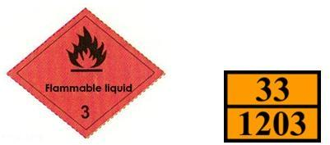

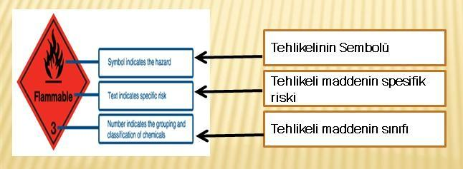
Figure 1.1 Label Reading

Custom Labels and Placards
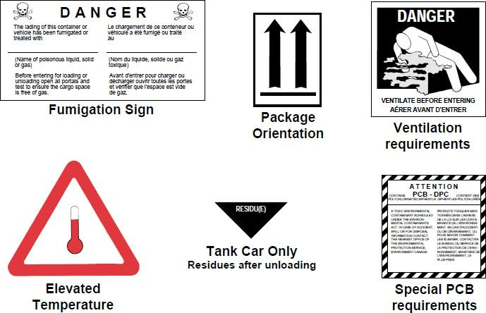
Figure 1.2 Custom Labels

  - Separation Tables for Dangerous Goods on Board and in Port: Decomposition
Segregation is the process of separating two or more items or items that are deemed to be mutually incompatible, whose packing or stacking may cause unnecessary hazards in the event of leakage, spillage or any other accident.
However, as the extent of hazards created may vary, the segregation arrangements required may likewise vary.Segregation is achieved by maintaining certain distances between incompatible dangerous goods or by requiring one or more steel bulkheads or decks to be placed between them, or a combination of these.The distance left between such dangerous goods can be filled with other loads compatible with the dangerous goods or objects in question.

Parsing terms
The following segregation expressions are described elsewhere in this section as they also apply to packaging of cargo transport units and segregation on different types of ships:
- “Should be kept away”;
- “must leave”;
- “It should be kept separate by means of an entire compartment or partition”;
- “The whole passing must be separated longitudinally by a compartment or partition”

Parse table
The general separation provisions between various dangerous goods classes are shown in the "separation table" given below.
Since the properties of substances, materials or objects in each class may be quite different;For certain provisions on segregation, if there are conflicting provisions, since these provisions will take precedence over general provisions, the list of dangerous substances will always be consulted.

CLASS | 1.1  1.2  1.5 | 1.3  1.6 | 1.4 | 2.1 | 2.2 | 2.3 | 3 | 4.1 | 4.2 | 4.3 | 5.1 | 5.2 | 6.1 | 6.2 | 7 | 8 | 9
Explosives 1.1, 1.2, 1.5 | * | * | * | 4 | 2 | 2 | 4 | 4 | 4 | 4 | 4 | 4 | 2 | 4 | 2 | 4 | x
Explosives 1.3, 1.6 | * | * | * | 4 | 2 | 2 | 4 | 3 | 3 | 4 | 4 | 4 | 2 | 4 | 2 | 2 | x
Explosives 1.4 | * | * | * | 2 | 1 | 1 | 2 | 2 | 2 | 2 | 2 | 2 | x | 4 | 2 | 2 | x
Combustible gases 2.1 | 4 | 4 | 2 | x | x | x | 2 | 1 | 2 | x | 2 | 2 | x | 4 | 2 | 1 | x
Toxic and non-flammable gases | 2 | 2 | 1 | x | x | x | 1 | x | 1 | x | x | 1 | x | 2 | 1 | x | x
Toxic gases 2.3 | 2 | 2 | 1 | x | x | x | 2 | x | 2 | x | x | 2 | x | 2 | 1 | x | x
flammable liquids 3 | 4 | 4 | 2 | 2 | 1 | 2 | x | x | 2 | 1 | 2 | 2 | x | 3 | 2 | x | x
Flammable solids (including 4.1 self-reactive substances and solid desensitized explosives) | 4 | 3 | 2 | 1 | x | x | x | x | 1 | x | 1 | 2 | x | 3 | 2 | 1 | x
Substances prone to sudden explosion 4.2 | 4 | 3 | 2 | 2 | 1 | 2 | 2 | 1 | x | 1 | 2 | 2 | 1 | 3 | 2 | 1 | x
Substances which, in contact with water, emit flammable  gases | 4 | 4 | 2 | x | x | x | 1 | x | 1 | x | 2 | 2 | x | 2 | 2 | 1 | x
Oxidizing substances (active substances) 5.1 | 4 | 4 | 2 | 2 | x | x | 2 | 1 | 2 | 2 | x | 2 | 1 | 3 | 1 | 2 | x
Organic peroxides 5.2 | 4 | 4 | 2 | 2 | 1 | 2 | 2 | 2 | 2 | 2 | 2 | x | 1 | 3 | 2 | 2 | x
Toxic substances 6.1 | 2 | 2 | x | x | x | x | x | x | 1 | x | 1 | 1 | x | 1 | x | x | x
Infectious substances 6.2 | 4 | 4 | 4 | 4 | 2 | 2 | 3 | 3 | 3 | 2 | 3 | 3 | 1 | x | 3 | 3 | x
radioactive material 7 | 2 | 2 | 2 | 2 | 1 | 1 | 2 | 2 | 2 | 2 | 1 | 2 | x | 3 | x | 2 | x
Corrosive substances 8 | 4 | 2 | 2 | 1 | x | x | x | 1 | 1 | 1 | 2 | 2 | x | 3 | 2 | x | x
Various dangerous goods 9 and pens | x | x | x | x | x | x | x | x | x | x | x | x | x | x | x | x | x

The numbers and symbols in the table have the following meanings:
- 1 – “Keep away”;
- 2 – “Must leave”;
- 3 – “Separated by an entire compartment or partition”;

- 4 – “The whole passing through must be separated longitudinally by a compartment or partition”
- X – The Dangerous Goods List should be consulted to verify whether there are special segregation provisions.
The classification of dangerous goods according to their classes is made on the ship and at the port within the scope of the IMDG Code.In the classification, the Chemical Substance Purchase, Use, Storage and Safety Information instruction is used.

  - Separation Distances and Separation Terms of Dangerous Goods in Warehouse Storages:
Safety Data forms are used in the purchase, use and storage of dangerous cargo in storage.

- HANDBOOK ON DANGEROUS LOADS HANDLED ON THE COASTAL FACILITY
The port facility, which carries out dangerous cargo handling activities, in order to contribute to the safe execution of the said activities;
- Hazardous substance classes,
- packages of dangerous goods,
- packaging,
- tags,
- marks and packing groups,
- Separation tables on the ship and in the port according to the classes of dangerous goods,
- Separation distances of dangerous goods in warehouse storage,
- parsing terms,
- Dangerous cargo documents,
- Dangerous loads emergency response action flow chart
- Emergency contact information
- There is a Hazardous Materials Manual, which includes the location and usage instructions of emergency equipment and coastal facility rules.

- OPERATIONAL MATTERS

  - Procedures for safe berthing, mooring, loading/discharging, sheltering or anchoring of ships carrying dangerous goods day and night.

Giresunport.Mertcan Denizcilik Liman Hizmetleri İç ve Dış Ticaret Ltd. Şti. in ship docking operations.Sti.Imported ships are allowed to dock after the permission of the Port Authority, the permission of the Coastal Health Inspection Center Medical Office, the compliance of the Sea Port Branch Directorate of Passport and Port Operations Authority and the Customs Directorate control procedures.Ships carrying cargo are docked with the permission of the Port Authority and the approval of the Customs Directorate.
Ship requirements for operations such as safe berthing, docking, loading and unloading of ships are specified in the ship suitability system procedure and compliance is checked by Giresunport.
Operations such as safe berthing, docking, loading and unloading of ships are carried out by taking ISGOTT into consideration.

  - Procedures for additional measures to be taken according to seasonal conditions for the loading and unloading of dangerous goods.
    - No explosive or flammable liquid cargoes should be loaded without an open cover, which will react dangerously neither in stormy weather nor in contact with water, while it is raining.
    - Dangerous solid bulk cargoes that can turn into flammable or toxic vapors or cause simultaneous explosion in contact with water should be kept as dry as possible.Such loads should only be transported under dry weather conditions.
    - Due to the nature of explosives;Transporting dangerous goods in electrically charged adverse weather conditions requires great care, especially in rainy weather conditions.
    - Seasonal In extremely hot weather, it should be taken into account that dangerous cargo loading/unloading operations are preferred in the morning or evening hours instead of noon.
    - In case of severe storm warnings, port foremen, technicians and ships are informed.
    - According to the severity of the storm to come, it is ensured that the ship machinery is always ready for action in the fastest way.
    - In heavy rainy weather, filling / unloading activities are suspended, taking into account personnel safety.
    - Loading and unloading operations are suspended in case of storms, sudden strong winds and lightning strikes.

    - In case of snow and icing, port machinery and transfer vehicles are not allowed to operate until the slippery environment is eliminated. When the environment is safe, the vehicles operate at the safest speed.
    - If the ship under operation leaves the port for compelling reasons before the operation is completed, both the Port Authority and the Customs Directorate are informed.
    - The relevant procedures are specified in the ship/coast safety checklist.

  - Procedures for Keeping Combustible, Flammable and Explosive Loads Away from Spark-Creating/May Create Operations and Not Operating Vehicles, Equipment or Tools that Create/Create Sparks in Dangerous Goods Handling, Stacking and Storage Areas:
Before performing a hot work at the facility, the responsible company officer who will perform the hot work will have a written authorization issued by the port administration to perform this hot work.Such authorization will include details of the hot workplace as well as the safety measures to be followed.Necessary permissions will be obtained from the Port Authority before starting hot work and operations.
In addition to the security measures required to be taken by the port administration, additional security measures required by the ship and/or interface will be taken, together with the ship and/or interface responsible(s) responsible for the hot work, before starting the hot work.
These additional security measures will include:
Frequency of inspection and re-inspection of local areas and adjacent areas, including testing by approved testing organizations to ensure that areas will remain free and free of flammable and/or explosive atmospheres and that there is no oxygen deficiency;
Removal of dangerous goods and other combustible materials from work areas and adjacent areas.Substances to be removed from the said areas;including lime, sludge, sediment and other potentially flammable materials.
Combustible building materials (eg;beams, wooden partitions, floors, doors, wall and ceiling coverings) against accidental ignition.
In order to prevent the spread of flames, sparks and hot particles from work areas to adjacent areas or other areas;sealing and sealing open pipes, pipe passages, valves, joints, cavities and open parts.
A copy of the hot work authorization and safety precautions will be posted in the area adjacent to the work area, as well as at the entrance to each work area.Authorization

and security measures to be taken will be posted in a place where all employees who will take part in the hot work can see it, and this will be clearly understood by the employees.
While performing hot work,
Checks will be made to ensure that conditions have not changed;and
Based on the completion of this work during the hot work and for a sufficient period of time after its completion, an effective fire control will be carried out in the hot work area as well as in the adjacent areas where a hazard from heat transfer may occur.
For additional more detailed information and procedures regarding hot works and processes, the document "International Safety Guidelines for Oil Tankers and Terminals (ISGOTT)" shall be consulted.Permission will be granted for the works to be carried out on the facility and dock in accordance with ISGOTT and the Work Permit Procedure.
The Port Facility Occupational Safety Procedure will also be applied.Heat treatment is not allowed at the quay on ships berthed and during the discharging/loading of these ships.
- The hot work permit area and safety precautions must be easily visible and clearly understandable by those who will perform hot work.
- Dangerous loads and other flammable materials should be removed from work areas and adjacent areas.
- When performing hot work, checks should be made to ensure that the conditions have not changed. A sign stating the permit for the hot work to be carried out and the safety precautions to be taken should be hung at the work area and all work area entrances, and at least one fire extinguisher or other suitable fire extinguishing equipment should be ready for use. , along with all its equipment, should be kept in an easily accessible place.
- In order to prevent flames, sparks and hot particles from spreading from work areas to adjacent areas or other areas, open pipes, pipe transitions, valves, joints, gaps and open parts must be closed and sealed.Dangerous loads and other flammable materials should be removed from work areas and adjacent areas.

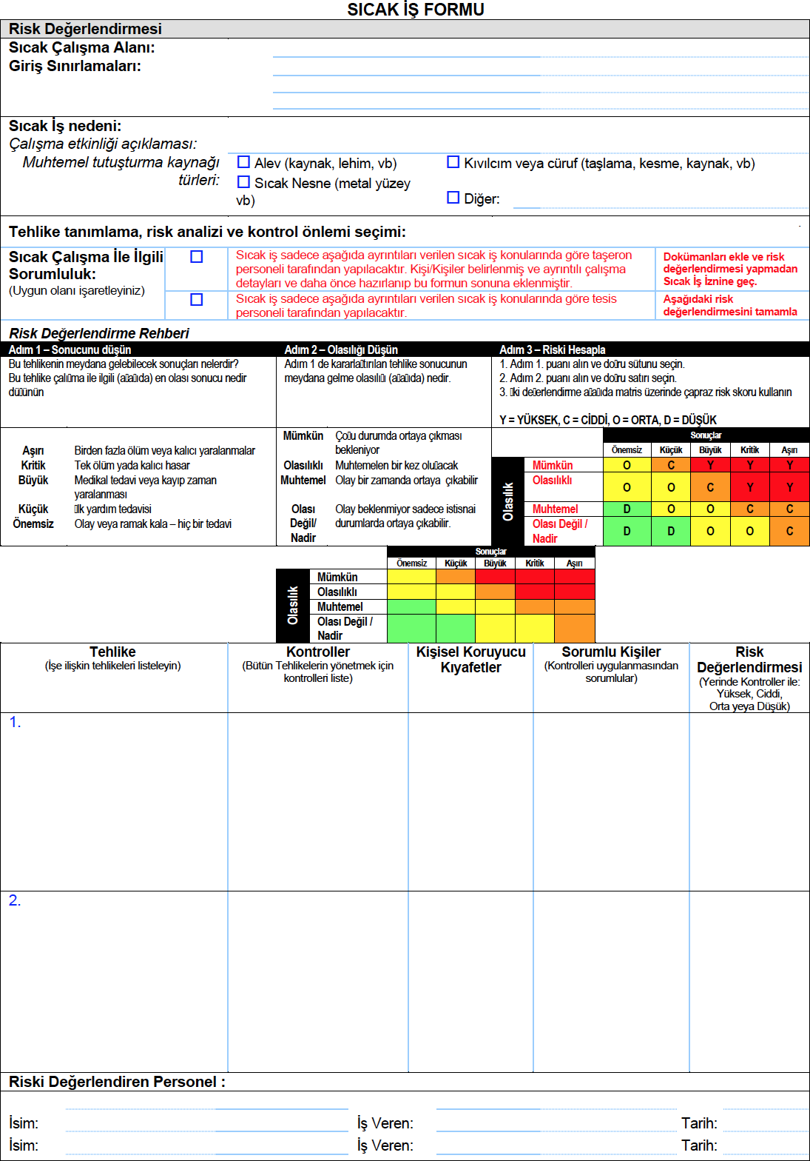
- During hot work, upon completion of this work and for a sufficient period thereafter, effective observation should be made in the hot work area as well as in adjacent areas where a hazard from heat transfer is likely to occur.

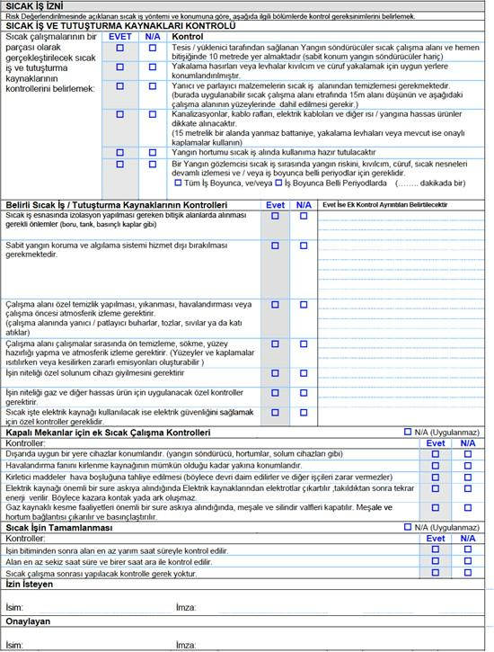

- DOCUMENTATION, CONTROL AND REGISTRATION

  - All mandatory documents, information and documents related to dangerous goods, procedures for their supply and control by the relevant people.
SDS regarding hazardous substances is obtained and recorded.The documents are checked by the authorities and revised when there is a change related to the relevant process.Relevant documents are kept together with the ship file.

  - Procedures for Keeping Up-to-Date List of All Dangerous Goods in the Coastal Facility Site and Other Related Information Regularly and Completely:
The records of dangerous goods handled at our port will be kept by the Operations department, including the following information.
    - UN Number,
    - PSN name, (Proper Post Name)
    - Class, (with sub-hazards)
-
- Packing Group ( Class 3, 4.1, 4.2, 4.3, 5.1, 6.1, 8, 9 )
    - Whether it is a Marine Pollutant,
    - Buyer,
    - Sender,
    - Container / Packaging , number,
    - seal number,
    - Additional Information (Ignition degree, viscosity, etc.)
    - Where it is stored in the Port Area
    - Length of stay in port
This information is kept in a computer environment or in a file order so that only authorized personnel can access it and is displayed when requested.

  - Procedures for Controlling Dangerous Goods Arriving at the Facility Properly Identified, Using Correct Shipping Names of Dangerous Goods, Certified, Packed / Packed, Labeled and Declared, Loaded and Transported Safely to Approved and Legal Package, Container or Cargo Transport Unit and Reporting the Control Results:
Dangerous goods, which constitute our main activity at the port, are recorded manually.Vehicle and packaging controls are carried out with control forms created by TMGD specifically for the loads handled at the facility.

In addition, in our container filling/unloading areas carrying dangerous cargo defined within the scope of ISPS;
- Regarding IMDG labeled loads, the statements of the agencies are acted upon.
- The agency that makes its declarations enters the container information into the system and carries out the registration process.
- A Container/Vehicle Packing Certificate is issued for container/vehicle loading in areas where cargo transport units are unloaded (CFS Areas).
- The port checks that each cargo transport unit arriving at the port to be transported by sea has a "Container/Vehicle Loading Certificate".Cargo transport units without the said certificate are not allowed to be loaded onto the ship.
- If there is no appropriate label according to the hazard class numbers declared in the discharge and loading of IMDG labeled loaded containers, or if there is a label but it is not declared in the system, a label appropriate to the load is attached to the container.
- During the acceptance phase of the container to the field, IMDG labeled containers are taken to the previously determined area on the field during the night shift.This task is carried out by Operations Field Planners.
Container unloading operation carrying dangerous cargo;
When an unloading request comes for IMDG labeled containers, the necessary information is provided to the personnel by the Field Planning Team.
- In CFS areas, hazardous cargoes (IMDG) including flammable, poisonous, oxidizing and corrosive substances classified by the International Maritime Organization (IMO) are handled by taking precautions within the framework of Environmental, Occupational Health and Safety rules.Before the handling process, in the material safety form (MSDS/SDS) of the dangerous goods to be handled;Hazard definitions, first aid measures, exposure and personal protection methods are explained to all employees involved in the operation by the field manager.

  - Procedures for obtaining and maintaining a safety data sheet (SDS).
It is obligatory to have a Dangerous Goods Safety Data Sheet (SDS) containing the following information together with the dangerous goods to be transported by road, railway, airway and seaway.
    - UN Number,
    - PSN name (Proper Shipping Name,) (Required for sea freight)
    - Class, (with sub-hazards)
- Packing Group ( Class 3, 4.1, 4.2, 4.3, 5.1, 6.1, 8, 9 )

    - Whether it is a Marine Pollutant,
    - Tunnel Restriction Code (Required for road transport.) Relevant forms are stored in digital or physical media for one year.
  - Procedures for keeping records and statistics of dangerous goods.
Systematic records of hazardous products coming to the port from Giresunport are recorded on the operating system used.Reports and statistical data can be obtained from the system as computer data at any time.

  - Information on the Quality Management System
As Giresun Port, all our activities carried out in line with our continuous improvement goals are carried out in an integrated manner with management systems.Our company has ISO 9001, ISO 14001, ISO 45001 management systems documents obtained from the relevant authorized certification bodies.The documents mentioned in this guide are numbered and recorded and made available to the relevant persons within the company.Within the scope of these documents, we are subject to internal and external audits at least once a year, and our activities are carried out to continuously increase our stakeholder satisfaction and the importance we attach to human and environmental health.

- EMERGENCIES, EMERGENCY PREPAREDNESS AND RESPONSE

  - Intervention Procedures for Dangerous Cargoes and Dangerous Situations Mixed with Dangerous Cargoes that Create/Can Create Risk to Life, Property and/or Environment:
“As stated in the Emergency Plan, interventions are made as follows.
    - It covers the work of emergency health services and emergency teams to quickly identify the emergency and emerging needs, to establish multi-directional communication, to quickly transport sufficient number of correct equipment and trained staff to the scene.
    - Relevant plans and instructions are renewed and revised to cover changes and events that may occur over time.Renewals also reflect emerging legal changes.
    - Emergency instructions;It is distributed as a controlled copy to the employees who cannot be reached electronically by the relevant department manager/responsible.

    - By the business;Considering the occurrence, region and time of the emergency, the appropriate instruction in the relevant documents section of this procedure is implemented.
    - After the emergency is taken under control, all details are recorded in the forms in the plan/instructions specified in the relevant documents section.
    - In order to prevent diseases and injuries that may occur as a result of emergency events, the work accident investigation and notification form is filled and the preventive measures specified in the form are taken.
    - It is carried out according to the communication and Communication Instruction to be made with the 3rd parties during the Emergency.
    - In order to prevent diseases and injuries that may occur as a result of emergency events, the work accident investigation and notification form is filled and the preventive measures specified in the form are taken.
    - After the emergency, if there is a need for revision in existing methods, the existing instructions are revised.
    - Corrective and Preventive Action is initiated after the emergency.
    - Activities related to the measures to be taken are included in the Occupational Safety and Environment program.
    - Every emergency situation is taken as an agenda item in the Management Review Meeting.
If a fire occurs as a result of situations that require an emergency, intervention is carried out in the following ways.
      - Personnel who see the fire should not only report the fire to the door security by phone, but should also use the fire extinguishers around them without risking themselves and should never wait for the fire department for the first response.
      - There are enough fire extinguishers, hose trolleys, foam units, sprinkler facilities and monitors in the enterprises.
      - A firefighting team list is created.Their duties are written next to their names in the list.An extinguishing team is made in front of the personnel working in the works that require organization at the last moment using the hose team, foam cannon.Others' direct duties are written.Like a fire water pump attendant.
      - It is ensured that the personnel use all firefighting equipment.If there is no personnel in the fire fighting team, the trained personnel can back up the personnel who were not in the operation at the time of the fire.
      - The personnel shift list is created taking into account the firefighting team list.It is ensured that personnel who have received first aid training are included in the shift list.

      - Preventing a fire is the most important duty and responsibility of all terminal personnel.

  - Information on the Opportunity, Capability and Capacity of the Coastal Facility to Respond to Emergency Situations:
The possibility of responding to emergencies that may be encountered during 24 hours is limited by the technical possibilities and manpower of the facility.In natural disasters or in emergencies where the facilities of the facility may be insufficient, public or other private sector facilities are utilized.The facilities to be used in case of fire are in the emergency plan, and the equipment to be used in case of spillage is as in ANNEX-14. It is done as stated in the emergency plan.
There is an automation security system in the port to stop operations in case of emergency.
To the detectors in the port, a possible dangerous situation is detected in advance and an opportunity for intervention is created.
There is 1 emergency container in the terminal and there is professional fire equipment in it.The terminal has enough absorbent pads against fuel spills, barriers for spills at sea, skimmers, and other spill response equipment.

  - Regulations regarding the first response to the accidents involving dangerous goods (first aid procedures, first aid possibilities and capabilities, etc.)
Emergency response team lists and what to do in case of emergency are listed in the "Emergency Plan".In order for the teams to be constantly ready for emergencies, ISPS Code exercises are held periodically, a spill exercise at sea, a land spill exercise periodically, an earthquake drill periodically, and a fire drill periodically.In addition, all trainings required for the teams to gain skills such as "emergency response level 1 and 2, emergency equipment usage training (Draeger pas colt respiratory mask usage training, etc.), fire safety training, first aid training, ISPS code drills" are given by authorized institutions. and certifications are kept up to date.

  - Notifications to be made inside and outside the facility in case of emergency
How relevant notifications should be made is as stated in procedure no. GPO-40.

  - Accident reporting procedures
In case of any work accident or near miss, the OHS unit creates an evaluation report and corrective actions are evaluated.

  - Coordination, support and cooperation method with official authorities
In any emergency, the response is carried out in coordination with the official authorities.In case of a fire, the local fire department is informed and asked to support the response.In emergencies arising from sabotage and terrorist activities, coordination with local security units is ensured.In cases such as natural disasters, the fire department is contacted if necessary, and coordination with AFAD is provided if necessary.In case of spillage at sea, coordination is ensured by contacting the Main Search and Rescue Coordination Center.In case of work accidents, notifications are made to the Ministry of Labor and Social Security.

  - Emergency evacuation plan for the removal of ships and vessels from the shore facility in case of emergency.
It is done as mentioned in the emergency plan.

  - Procedures for the handling and disposal of damaged dangerous cargoes and waste contaminated by dangerous cargoes
Hazardous wastes are stored at the facility in line with the Waste Management Regulation and delivered to companies licensed by the Ministry of Environment and Urbanization and are disposed of.
In order to prevent pollution caused by accidental spills and similar events, an action is planned to restore the crime scene immediately, depending on the type of waste, from the moment the burden of the incident is found.Waste Manager is responsible for the planning and monitoring of the action.

Necessary measures are taken to minimize the formation of hazardous waste.Within the scope of these measures, employees are made aware of waste generation and what to do in an emergency.In case of emergencies such as possible leakage and spillage, methods such as having an absorbent material are applied.

  - Emergency drills and their records
Our drills are held at the times specified in the Training Plan.The records of the exercises are kept with the Training Participation Form and evaluated with the Exercise Report.
Annual Exercise Plan
Sequence  No. | Planned Exercise | PIECE | Education  time | Participants
1 | Man Rescue from  Confined Space | 1 | 30  minutes | emergency personnel

2 | Black Spill Drill | 1 | 30  minutes | emergency personnel
3 | Sea Spill Drill | 1 | 2 hours | Emergency personnel – Marine pollution  response team
4 | ISPS Drill /  Penetration Drill | 1 | 30  minutes | Related personnel
5 | Fire drill | 1 | 2 hours | All staff

  - Information on fire protection systems
The equipment list is kept up to date with the Fire Fighting System Material List and its maintenance is carried out annually by a TÜRKAK accredited organization.

  - Procedures for the approval, inspection, testing, maintenance and availability of fire protection systems
There is a fire brigade report approved by the fire brigade department in our port.Fire drills are held periodically every year.Fire systems are kept ready at all times in the terminal.Periodic controls of the equipment are carried out regularly and recorded.

  - Precautions to be taken in cases where fire protection systems do not work

Fire protection equipment is critical equipment.First of all, if such equipment is out of order for some reason, necessary action is taken.Within the scope of the Process Safety Procedure, critical equipment deactivation forms are used and this form is shared with the relevant people.In the daily shift reports, it is stated that such equipment is disabled and how precautions are taken, and it is ensured that the entire facility is aware of the situation.If the equipment to be disabled is very critical and there is a dangerous situation that may be encountered during the operational process, operations can be stopped if necessary by obtaining approval from the Operations Manager.
If an equipment change is made, it is submitted to the approval mechanism of the relevant authorities.If accepted, that change will be made.
If an equipment change is made, the Change Management Procedure is applied and submitted to the approval mechanism of the relevant authorities.If accepted, that change will be made.

- OCCUPATIONAL HEALTH AND SAFETY

  - Occupational Health and Safety Measures

Priority is given to occupational health and safety issues at the port.All kinds of work carried out in the port area are evaluated and carried out within the scope of risk assessments, occupational safety analyzes and work permit procedures, provided that certain procedures and instructions are followed.Before the work, all personnel who will work in the relevant work are given trainings on safety precautions, and orientation is made on what to do in case of an emergency.It is mandatory to use personal protective equipment in the port area and in all working areas related to the port.

    - To provide and maintain reliable and non-hazardous workplace, equipment and working methods,
    - To provide and maintain safe entry and exit to workplaces,
    - To provide the necessary supervision and control to ensure that the workers are protected against the risks of accidents and injuries arising from their work or the execution of the work,
    - To provide workers with all kinds of personal protective equipment and protective clothing and all kinds of life-saving devices that are reasonably needed, since protection against the risks of accident and injury cannot be provided in any other way;
    - To provide and maintain appropriate and adequate first aid and rescue facilities,
    - Developing and establishing appropriate procedures to deal with any emergencies that may arise;
    - Prevention and protection from fire and explosion,
    - Safe entry and exit to ships, holds, piers, equipment and lifting devices,
    - transport of workers,
    - Opening and closing of hatch covers, protection of hatches, working in warehouses,
    - Construction, maintenance and use of lifting and other loading and unloading devices,
    - Construction, maintenance and use of scaffolds,
    - Use of ship's equipment (rigging) and cores,
    - Testing, inspection and documentation of loose equipment, including lifting devices, chains and ropes, and the plow and other lifting equipment on the load itself,
    - Passages will be left for entry and exit wide enough to allow safe use of vehicles and loading and unloading devices.
    - Where necessary and possible, separate passages will be left for the entrances and exits of pedestrians, these will be of sufficient width and, as far as possible, they will be kept separate from the passages used by vehicles.
    - of the workers;Protection of themselves or others;It requires them not to misuse the security equipment and devices provided for their employees or to interfere

with their operation unnecessarily, to take care of their own safety or the safety of others who may be affected by their acts and omissions at work, to take corrective measures in order to take corrective measures, and any situation that they believe is dangerous and that they cannot fix. Measures shall be taken to promptly notify their superiors.
    - Every place where port works are seen and their entrances and exits will be illuminated appropriately and adequately.
    - Lifting devices shall be appropriately and visibly marked and adequately illuminated, if necessary, if obstacles that are likely to endanger the movement of vehicles and persons cannot be removed for practical reasons.
    - All surfaces used for vehicle traffic or for the accumulation of goods or materials will be suitable for the purpose and these conditions will be duly maintained.
    - If the goods and materials are stacked and stacked and transferred again from these stacks and stacks, the work in question will be carried out in a reliable and orderly manner, taking into account the characteristics of the goods and materials and their packaging characteristics.
    - Passages will be left for entry and exit wide enough to allow safe use of vehicles and loading and unloading devices.
    - Where necessary and possible, separate passages will be left for the entrances and exits of pedestrians, these will be of sufficient width and, as far as possible, they will be kept separate from the passages used by vehicles.
    - Appropriate and sufficient facilities will be provided for fire extinguishing in the places where port works are carried out and will be made available for use.
    - Dangerous parts of machinery shall be effectively contained unless they are in a safe condition or structure, such as when they are operatively enclosed.In the event of an emergency, effective measures shall be taken to immediately cut off the power operating any machinery.
    - In cases where it is necessary to carry out any repair, maintenance or cleaning work on the machines that would endanger anyone, the machine shall be stopped before the start of the work and ensure that the machines are not restarted until the repair and maintenance work is completed, provided that a responsible person is able to operate the machine for a test or an adjustment that is not possible while the machine is stopped. Adequate measures will be taken.
    - Only authorized persons shall be permitted to remove the enclosure, render inoperative or remove a safety device for the purpose of cleaning, adjusting or repairing it when necessary for the work being performed.
    - If any enclosure is removed, adequate precautions shall be taken and replaced as soon as possible.
    - If any safety equipment is removed or rendered inoperable, it shall be replaced or rendered operational as soon as possible, and until this is done, measures shall be taken to ensure that the relevant equipment cannot be used or operated accidentally.
    - All electrical equipment and installations shall be constructed, installed, operated and maintained in a way that prevents danger and shall comply with the standards accepted by the competent authority.

    - When a ship is loaded or unloaded berthed or berthed to a pier or another ship, a properly installed and anchored entry-exit facility shall be provided and available for use at all times.
    - Where it is necessary to transport workers by sea to and from the ship or elsewhere, adequate measures shall be taken to ensure the safe embarkation, transport and disembarkation of workers;The conditions under which the boats used must comply with this purpose will be determined.
    - Where workers have to be transported to or from a workplace by road, means of transport provided by the employer will be safe.
    - Entry to the hold or cargo deck of the ship shall be by a fixed ladder or, when this is not possible, by means of suitable dimensions, durable and suitable construction, fixed ladder-stepped post or carved step, by other means accepted by the competent authority.
    - In or on the decks on which workers are working, any gaps where workers and vehicles may fall shall be adequately guarded.
    - The hatches that are not equipped with a burial of sufficient height and strength will be closed and guarded when not in use, except for short interruptions to work, and a responsible person will be charged with ensuring that these precautions are met.
    - The entire lifting device, every part of the loose equipment, and the lifting device constituting an integral part of the load, or the sling, well designed and constructed for the purpose in which it is used, well repaired and maintained of sufficient strength, shall be properly installed, safely and properly used, and in particular It will not be loaded beyond its safe working capacity, unless it is used for testing under the supervision of a competent person.
    - All lifting devices and every part of loose equipment shall be tested by a competent person in accordance with national legislation before first use and after any part which is likely to affect its safety has been substantially modified or repaired.
    - Lifting devices forming part of the ship's equipment shall be retested at least once every five years.
    - Lifting devices installed on shore will be tried again at times to be determined by the competent authority.
    - Upon completion of any testing of the lifting device and loose piece of equipment in accordance with this clause, the device or equipment shall be fully inspected and documented by the person performing the testing.
    - Each lifting device (except for the ship's overhead crane) having only one safe load limit shall be clearly stamped on each piece of free equipment, and if this is not practicable, it shall be marked by other means.
    - Every lifting device with variable safe load rates (except the ship's vertical crane) shall be equipped with suitable means by which the device operator can determine the device's safe load limit in each mode of use.
    - All kinds of dangerous goods;will be packed, marked, loaded and unloaded, stacked and stacked in accordance with the requirements of the international rules

regarding the loading and unloading of dangerous goods at ports, which are applied to the transport of dangerous goods by sea.
    - Dangerous materials;shall not be loaded or unloaded unless it is packed, marked and labeled in accordance with the international rules for the carriage of such goods.
    - If the containers and containers of dangerous goods are broken or damaged in a dangerous way, port works other than those necessary to eliminate the danger in the said area will be stopped, and the workers will be sent to a safe place until the danger is eliminated.
    - Adequate precautions shall be taken to prevent workers from being exposed to toxic or harmful substances and agents or being in oxygen-free or flammable spaces.
    - of the workers;When they are required to enter closed spaces where toxic or harmful substances are expected or where oxygen deficiency is possible, adequate precautions will be taken to prevent accidents or to prevent the occurrence of a situation harmful to health.
    - Necessary measures will be taken to protect workers from the harmful effects of excessive noise in the workplace.
    - In the event that adequate protection against the risk of accident or health hazards cannot be provided by other means, the workers will be provided with the necessary personal protective equipment and clothing in reasonable proportions, and the workers will be obliged to use them while performing their jobs.
    - Workers will be held responsible for maintaining and storing personal protective equipment and clothing.
    - Personal protective equipment and clothing will be properly maintained by the employer.
    - In the event of an accident, adequate facilities shall be made available, including trained personnel, for the rescue of endangered workers, the rendering of first aid and the transport of the injured, to the extent possible without increasing the hazard.
    - No worker will be employed in port works who are not adequately trained or taught about the potential hazards associated with his work and the main precautions to be taken.
    - A lifting device or handling device shall only be used by a person who is at least 18 years of age, of sufficient ability and skill, or undergoing training under proper supervision and supervision.
    - No worker will be employed in port works who are not adequately trained or taught about the potential hazards associated with his work and the main precautions to be taken.
    - A lifting device or handling device shall only be used by a person who is at least 18 years of age, of sufficient ability and skill, or undergoing training under proper supervision and supervision.

    - Washing and cleaning facilities shall be provided at a reasonable distance from the working places in the ports, duly maintained, in sufficient quantity in accordance with the national legislation and practice.

  - Information on personal protective clothing and procedures for using them.

Personal protective equipment;all tools, tools, equipment and devices that protect the employee against one or more risks arising from the work carried out, affecting health and safety, worn, worn or held by the employee, designed for this purpose, in order to protect the person against one or more risks. A device, tool or material made up of a whole by the manufacturer, a detachable or non-separable protective device, tool or material used with equipment that is carried or worn without a protective purpose to perform a specific activity, for the comfortable and functional operation of personal protective equipment. means replaceable parts that are required and used only with such equipment.

    - PPE should provide adequate protection against all risks encountered during its intended use.
    - PPE designed and manufactured in such a way as to protect the user at the highest possible level during use in foreseeable conditions and in the intended direction, while carrying out hazardous work will be used.
    - The most appropriate level of protection to consider during design is the point at which the effectiveness of PPE begins to decline when exposed to the risk from the use of PPE or during normal business conduct.PPE suitable for this design will be used.
    - In the design of PPE, appropriate protection classifications will be taken into account where foreseeable conditions of use differ, such as different levels of the same risk factor can be distinguished.
    - PPE that is designed and manufactured in such a way that it will not cause hazards and other disturbing factors that may arise from its structure during use in foreseeable conditions will be used.
    - PPE material and parts, including substances resulting from deterioration, must not adversely affect the health and hygiene of the user.
    - Any PPE element that comes into contact with or is likely to come into contact with the user when worn should not be hard enough to cause irritation or injury, and should not have sharp edges or protrusions.
    - Restrictions caused by PPE on posture and movement of the body and loss of sensitivity in sensory organs should be minimized and PPE should not cause dangerous movements for the user or other persons.
    - Considering the movements to be made during the work and the postures of the body, PPE will be used which are designed and produced to ensure that the user

can easily stand in the right position and remain in place for the foreseen usage period.For this purpose, it should be ensured that PPE can be used most effectively with the help of adjustable and addable systems or by producing it in different body sizes, ensuring that it is suitable for the body structure of the user.
    - PPE, which is manufactured as light as possible, should be used so as not to reduce its durability and functionality.
    - If the same manufacturer has introduced PPE models of different types and classes to ensure simultaneous protection of adjacent parts of the body against these risks when more than one risk is involved at the same time, they should be used in harmony with each other.
All PPE used in GiresunPort are kept and used in accordance with the provisions of the “PERSONAL PROTECTIVE EQUIPMENT REGULATION AND THE REGULATION ON THE USE OF PERSONAL PROTECTIVE EQUIPMENT IN
WORKPLACES”.In addition, it is acted in accordance with the provisions of the regulation.

  - Closed Room Entry Permit Measures and Procedures
In our facility, OHS-P03 'Safe working procedure in Confined Areas' prepared by OHS is applied during closed area entrances.

- OTHER MATTERS

  - Validity of Dangerous Goods Conformity Certificate
Dangerous Cargo Conformity Certificate is valid until 15.05.2026

  - Defined Duties for Dangerous Goods Safety Advisor
As stated in 2.6.

  - Issues for those carrying dangerous goods that will arrive/leave the coastal facility by road
    - Dangerous goods are transported on public roads in accordance with the provisions of ADR, in an economical, controlled, serial, safe manner, without harming human health and with the least negative impact on the environment.
    - Parties involved in the transport of dangerous goods must take measures in accordance with the provisions of ADR, taking into account the nature and

extent of the foreseeable risks, in order to prevent damage and injury and, if necessary, to minimize their effects.
    - It is obligatory to use the labels, signs and orange plates defined in ADR in the transportation of dangerous goods.
    - Real and legal persons who will engage in transportation activities must have any of the K1, K2 authorization certificates according to the Road Transport Regulation.
    - In accordance with the provisions of ADR, drivers who will transport dangerous goods on national and international roads must have a Dangerous Goods Transport Driver Training Certificate (SRC5) / ADR Driver Training Certificate.
Vehicles carrying dangerous goods must have the following documents:
      - Transport document issued as specified in ADR Section 5.4.1,
      - Dangerous Goods Transport Driver Training Certificate (SRC5) as specified in ADR Section 8.2.2.8,
      - Picture identification document (ID card, driver's license or passport) for each personnel on duty in the vehicle,
      - Written instruction issued by the carrier to the driver as specified in ADR Section 5.4.3.
      - Multi-Mode Dangerous Goods Transport Form in ADR Section 5.4.5 for dangerous goods transported by more than one mode,
      - Valid ADR certificate of conformity for vehicles,
      - Dangerous Goods and Hazardous Waste Compulsory Liability Insurance policy for vehicles carrying dangerous goods.

  - Issues for those carrying dangerous goods that will arrive/leave the coastal facility by sea
    - At least twenty-four hours before the ship and sea vehicle carrying dangerous goods enter the port administrative area;Ships and marine vessels with a cruise time of less than twenty-four hours until they enter the port area submit a notification document containing detailed information about their cargo to the port authority in writing, right after their departure from the coastal facility.
    - Transportation should be done in a safe, secure and environmentally friendly manner, and all necessary precautions should be taken to prevent accidents and to minimize the damage when an accident occurs.
    - Classification, identification, packaging, marking, labeling and plating of dangerous goods are provided in accordance with the legislation.

    - It is ensured that dangerous goods are safely loaded, stacked, secured, transported and unloaded in approved and legal packaging, container and cargo transport unit.
    - All relevant personnel are trained on the risks of dangerous goods transported by sea, safety precautions, safe working, emergency measures, security and similar issues, and training records are kept.
    - It is ensured that the necessary safety measures are taken for dangerous substances that do not comply with the rules, are unsafe or pose a risk to people or the environment.
    - In the event of an emergency or accident, necessary information and support are provided to those concerned.
    - Dangerous goods accidents occurring in the area of responsibility are reported to the administration.
    - It ensures that the ship's equipment and devices are suitable for dangerous cargo transportation.
    - It requests all mandatory documents, information and documents related to dangerous goods from the coastal facility and the cargo person, and ensures that they accompany the dangerous cargo.
    - It ensures that the safety measures regarding loading, stacking, separation, handling, transportation and unloading of dangerous goods on the ship are fully implemented and maintained, and performs the necessary inspections and controls.
    - It controls that the dangerous goods entering the ship are defined, classified, certified, packaged, marked, labeled, declared in accordance with the procedure, and that they are safely loaded and transported to the approved and legal packaging, container and cargo transport unit.
    - It ensures that all ship personnel are informed and trained on the risks of transported, loaded and unloaded dangerous goods, safety precautions, safe working, emergency measures and similar issues.
    - It ensures that people who are qualified and trained in the loading, transportation, unloading and handling of dangerous goods work in a way that takes occupational safety precautions.
    - It cannot go out of the area allocated to it, cannot anchor, cannot approach the pier and pier without the permission of the port authority.
    - It applies all rules and precautions during navigation, maneuvering, mooring, berthing and departures in order for the ship to carry the dangerous cargo safely.
    - It provides safe entry and exit between the ship and the dock.
    - Informs its personnel about the practices, safety procedures, emergency measures and response methods related to dangerous goods on board.

    - It maintains the current lists of all dangerous goods on board and declares them to the relevant parties.
    - It takes the necessary safety measures for dangerous goods that do not comply with the rules, are unsafe, pose a risk to the ship, people or the environment, and notify the port authority.
    - Notifies the port authority of the dangerous cargo accidents that occur on the ship.
    - It provides the necessary support and cooperation in the controls made by the official authorities on the ship.
The relevant instructions and procedures are as follows;

      - Marine Tanker Loading and Discharging Instructions
      - Ship Compliance Instruction

  - Additional considerations to be added by the shore facility

ATTACHMENTS

- General site plan of the coastal facility

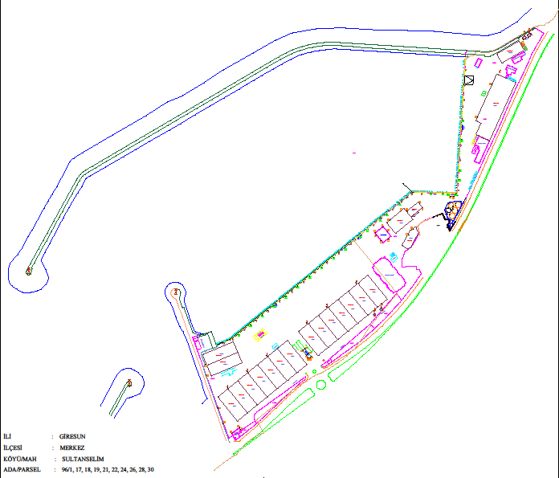

- General view photos of the coastal facility
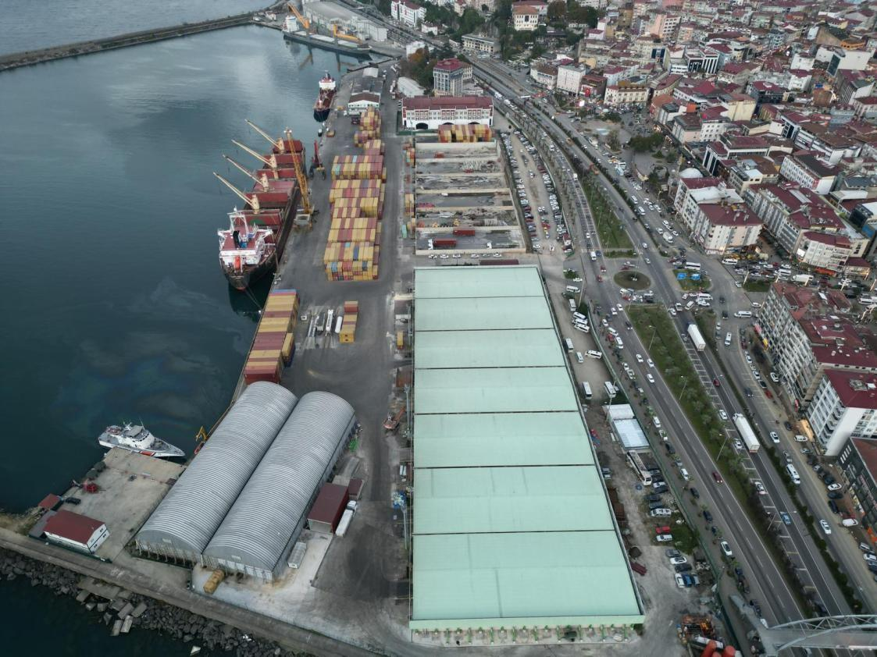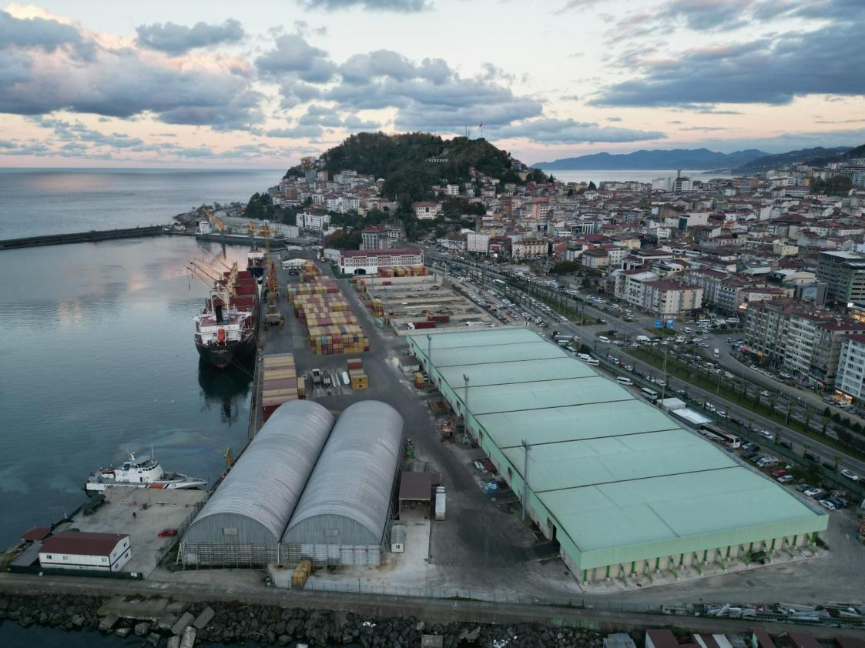

- Emergency contact points and contact information

EMERGENCY CONTACT INFORMATION
office | Telephone | office | Telephone | Fax
Environment, Urbanism and Climate Change Giresun Provincial Directorate | 04542157545 | Coast Guard Boat  Command | - | -
Coast Guard | 158
customs Directorate | 0454216 30 02
Giresun Port Authority | 04542161106 | POLICE | 155
Governorship | 04542820282 | GENDARME | 156
 |  | CUSTOMS HOUSING | 136
 |  | FIRE DEPARTMENT | 110
 | - | AMBULANCE | 112
Law Enforcement You Are Affiliated With: | Police District
Ship Calis Channel (VHF):
Security/Operations Radio Channel (UHF): | Single Channel Radio
Law Enforcement Radio Channel: | forms

- General layout plan of areas where dangerous cargo is handled

- Fire plan of areas where hazardous loads are handled
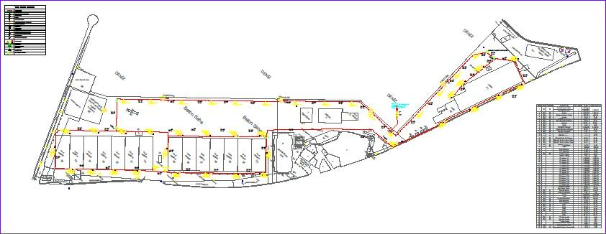

- General fire plan of the facility
It is as in the General Fire plan.

- Emergency Plan
Available.

- Emergency Assembly Place Plan

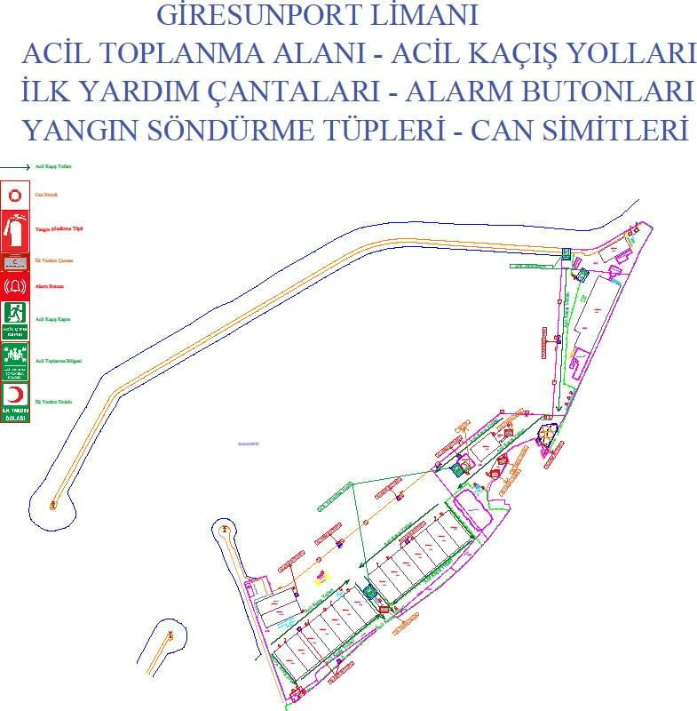

- Emergency Management Scheme

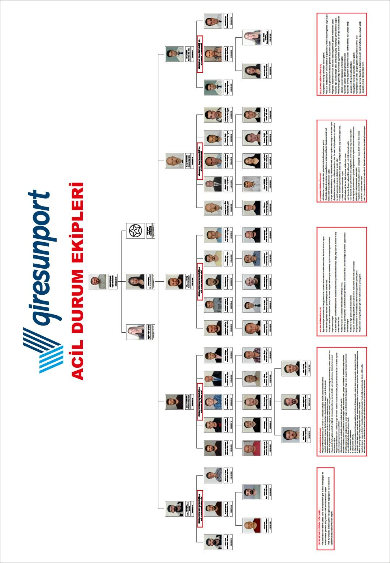

- Hazardous materials handbook
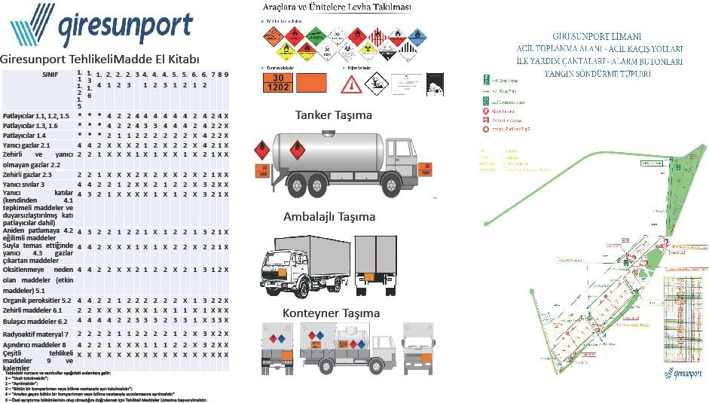

- For CTU and Packages Leak areas and equipment, entry/exit drawings
-

- Inventory of port service vessels
Not available.

- Sea coordinates of the port authority's administrative borders, anchorage locations and pilot disembarkation/embarkation points
- Port administrative area boundary The port administrative area of Giresun Port Authority is the sea and coastal area between the lines drawn in the true north direction from the coordinates below and bordered by the adjacent Turkish Territorial Waters.
  - 40º 58´ 27" N – 038º 38´ 33" E (Çam Burnu)
  - 40º 57´ 30" N – 038º 06´ 54" E (Giresun-Ordu Provincial Border)
- Anchorage areas
  - Anchorage area no. 1:The anchorage area for ships that do not carry dangerous goods under 5000 GT is the sea area formed by the coordinates below.

    - 40º 55' 12" N – 038º 21' 00" E
    - 40º 55' 12" N – 038º 21' 24" E
    - 40º 54' 54" N – 038º 21' 00" E
    - 40º 54' 54" N – 038º 21' 25" E
  - Anchorage area no. 2:The anchorage area of ships of 5000 GT and above that do not carry dangerous goods and military ships is the sea area formed by the coordinates below.
    - 40º 56' 00" N – 038º 24' 00" E
    - 40º 56' 00" N – 038º 24' 30" E
    - 40º 55' 37" N – 038º 24' 00" E
    - 40º 55' 37" N – 038º 24' 30" E
  - Anchorage area no. 3:The anchorage area of ships carrying hazardous materials, nuclear-powered military ships, ships to be quarantined, and ships to perform degassing is the sea area formed by the following coordinates.
. 1) 40º 56' 00" N – 038º 22' 45" E
- 40º 56' 00" N – 038º 23' 18" E
- 40º 55' 36" N – 038º 22' 45" E
- 40º 55' 36" N – 038º 23' 18" E
ç) Anchorage area no 4:The anchorage area of the ships that will dock at Bulancak Municipality Pier is the sea area formed by the coordinates below.
- 40º 57' 40" N – 038º 13' 00" E
- 40º 57' 40" N – 038º 14' 00" E
- 40º 57' 00" N – 038º 13' 00" E
- 40º 57' 00" N – 038º 14' 00" E
- Pilot pick-up and drop-off location 40º 55' 09" N – 038º 21' 39" E

- Emergency response equipment against marine pollution in the port facility

oil scraper | 1 pc
Barrier | 450m
50 m3 floating storage tank | 2 pieces
absorbent pads | 1000 pieces
mooring type boat | 1 pc
life vest | 10 units
half face gas mask | 10 units
full face gas mask | 5 pieces
Chemical resistant overalls | 10 units
Helmet | 10 units
Glasses | 10 units
Raincoat | 10 units
Boot | 10 units
gas measuring device | 2 pieces

- Personal Protective Equipment (PPE) Usage Map

The use of PPE is mandatory in the entire port area.

- Hazardous Substance Incidents Notification Form

Issue number- Date
Company / Institution
Sender |  | CONTACT INFORMATION
as required
PORT FACILITY
“DANGEROUS GOODS EVENT NOTIFICATION”
DATE:
1. When the accident occurred,
2. If the accident is known, how it occurred and the reason,
3. The place where the accident occurred (coastal facility and/or ship), its position and area of influence, ç) Information (name, flag, IMO number, owner, operator, cargo, if any) of the ship involved in the accident.
and amount, captain's name and similar information),
4. Meteorological conditions,
5. UN number of the dangerous substance, proper transport name (based on the legislation specified in the definition of dangerous substance) and amount,
Hazard class of the dangerous substance or sub-hazard division, if any, Packing group of the dangerous substance, if any,
Additional risks of the dangerous substance, such as marine pollutants, if any,

Sign and label details of the dangerous substance,
The characteristics and number of the package, cargo transport unit and container in which the dangerous substance is transported, if any,
Manufacturer, sender, carrier and receiver of dangerous goods
6. The extent of the damage/pollution,,
7. Number of dead and injured in the accident (if any),
8. How the accident was intervened,
9. From which organizations help is requested,
10. Other ships or neighboring facilities that may be affected by the accident,
FORM PREPARED BY:

Name and surname : Mission:
Signature :

- Control results notification form for dangerous cargo transport units (CTUs)

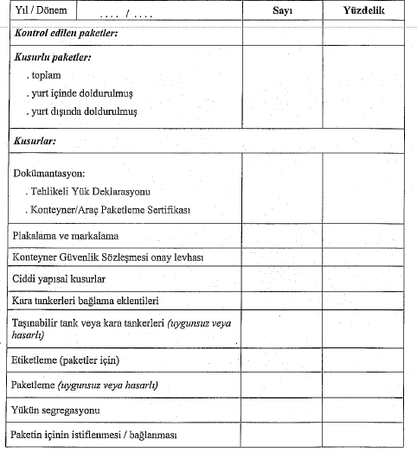

 | Revision Number | Release date | Revision date | Page Number
 | 0 | 04.01.2021 |  | 67
 | DANGEROUS GOODS GUIDE

- Other required attachments

  - Temperature control form

CONTAINER TEMPERATURE CONTROL FORM |  | History:
Container number:
Related load information:
SADT value:
Temperature measurement value:1. Measurement:…. 2̍̍. Measurement:….
- Measurement:….
- Measurement:….
NOTE:
controller
Name Surname/Signature

- Dangerous Goods Handling Guide Additional Cargo Notification (When necessary)
not relevant

